

Oceania > Australia > New South Wales > Sydney

Sydney

For other places with the same name, see Sydney (disambiguation).

Sydney is the Harbour City, and is the oldest and most cosmopolitan city in Australia with an enviable reputation as one of the world's most beautiful and livable cities. Brimming with history, nature, culture, art, fashion, cuisine and design, it is set next to miles of ocean coastline and sandy surf beaches. The city is also home to the Sydney Opera House and the Sydney Harbour Bridge, two of the most iconic structures on the planet. The gateway to Australia, it lies on the deepest natural harbour in the world and stretches for 140 kilometres.

Sydney is a major global city and an important finance centre in the Asia-Pacific region. The city is surrounded by nature and national parks, which extend through the suburbs and right to the shores of the harbour.

Districts

Sydney has a compact city core surrounded by sprawling suburbs, forming a vast metropolitan area. The city central is shaped roughly like a stubby palm-up left hand: the heel of the thumb as City South, the thumb as the district Darling Harbour, the first finger as The Rocks, the palm with the second and third fingers as City Centre - CBD and the rest as City East.

Sydney CBD

City Centre
Home to the busy centre of Sydney CBD, centre of government and finance but also home to many famous attractions (including the Opera House and the Royal Botanic Gardens), fine restaurants and shopping. Take ferries from Circular Quay to some of the Sydney Harbour Islands.

The Rocks
Just to the west of Circular Quay. Once the colonial village of Sydney, the Rocks is now a cosmopolitan area with history, views and shopping. It is the gateway to the iconic Sydney Harbour Bridge.

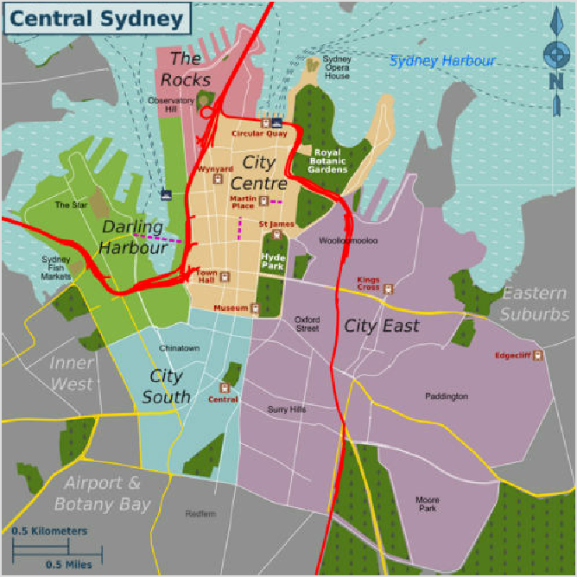Darling Harbour
The five Central Sydney districts
An extensive leisure and entertainment area immediately to the west of the City Centre. Take an early morning trip to the fish markets and follow up by exploring the restaurants, boardwalks, aquariums, wildlife and museums around Cockle Bay. Then find a maritime pub or hit The Star casino.

City South
The Haymarket, Chinatown and Central Station area is home to markets, cafes, Chinese culture and cuisine together with cheaper accommodation and shopping.

City East
Kings Cross, Darlinghurst, Surry Hills, Woolloomooloo and Moore Park. Busy nightlife, coffee shops, fashion and entertainment by day.

Sydney Harbour
Harbour Islands, Sydney Harbour National Park. Very much the highlight of Sydney, known for its beautiful waterways and views.

Greater Sydney
Greater Sydney, the sprawling suburbs in the vast city metropolitan area surrounding Central Sydney spread for up to 150 km westward from the CBD. The traveller visiting the suburbs will find less crowded beaches, parks, cheaper shopping, commercial centres, cultural festivals, hidden gems and the many national parks within the metropolitan area.

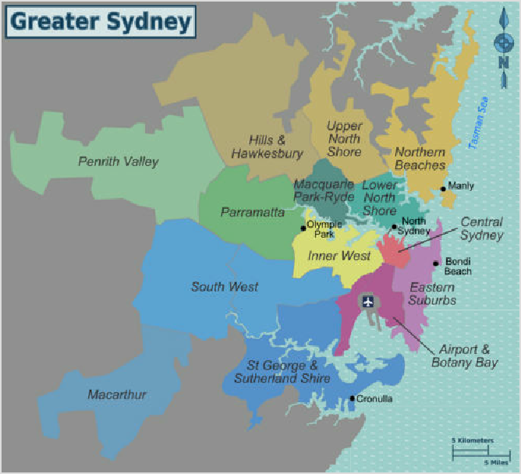Eastern Suburbs
Greater Sydney districts
Eastern Sydney lying Between Central Sydney and the sea, the Eastern suburbs includes the world- famous Bondi Beach along with famous harbour spots such as Watsons Bay which are popular for visitors and residents during summer. The Eastern Suburbs also has other popular beaches such as Clovelly, Coogee and Maroubra along with the famous suburb of La Perouse at the very end of the region on Botany Bay.

Airport & Botany Bay
Just south of Central Sydney. Bargain shopping and bayside walks near the Sydney Airport.

Inner West
Sydney's original suburb, just west of Central Sydney is now bohemian

and a hub of relatively low-price eats, shopping and inner-city culture. Also contains Sydney Olympic Park, the home of the Sydney 2000 Olympic Games and the White Bay Cruise Terminal.

Lower North Shore (Chatswood, Milsons Point)
Over the Harbour Bridge are leafy residential areas stretching northwards. The Lower North Shore also has major commercial and retail areas at North Sydney and Chatswood, many smaller boutique shopping areas, many parks, gardens and Sydney's famous Taronga Zoo.

Macquarie Park & Ryde
Contains picturesque parks overlooking Lane Cove and Parramatta Rivers, great East Asian food in Eastwood and a high technology hub known as Australia's "Silicon Valley".
Sydney Northern (Northern Beaches, Upper North Shore, Hills & Hawkesbury, Manly) Offers the laidback Northern Beaches, from Manly stretching north along the coast to Palm Beach. Includes leafy residential areas, national parks and rivers of the Upper North Shore as well as the highly religious Hills District and semi-rural Dural & Galston in Hills & Hawkesbury.
Sydney Southern (St George and Sutherland Shire, including Cronulla)
The St. George & Sutherland Shire enjoys access to the waterways of the St Georges River, Botany Bay and Port Hacking and is home to Cronulla and Captain Cook's Landing Place. Macarthur contains the Campbelltown and Camden areas.
Western Sydney (Parramatta, Penrith Valley (also referred to as "Outer West")) Stretching from Parramatta, Sydney's "second" CBD with plenty of history and shopping through the Penrith Valley (Outer West), out to the Blue Mountains.
Macarthur/South Western Sydney (South West, Macarthur, Camden)
The South West has some of the most vibrant immigrant communities in Sydney with growing ethnic enclaves in different parts of the district. Also, one of the fastest growing communities in New South Wales, shopping out to places like Camden or Picton.
Hawkesbury (Wisemans Ferry, City of Hawkesbury)
Outer region of Sydney that features the Hawkesbury River. Fruit farms and country living.

Understand

History
While originally settled 60,000 years ago, Sydney is the oldest European settlement in Australia, having been established as a British penal colony on 26 January 1788 by Arthur Phillip. This day is now celebrated as Australia Day to mark the establishment of a new nation, although also regarded by many as Invasion Day that marked the beginning of the British appropriation of Aboriginal land. The settlement was named "Sydney" after Thomas Townshend, 1st Viscount Sydney, who was the British Home Secretary at that time.

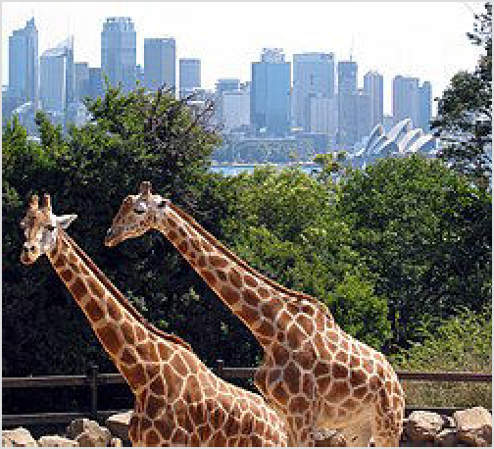People

Giraffes at Taronga Zoo, Mosman
Sydney is one of the most cosmopolitan cities on the planet, with a bit less than one third of its population born overseas. European settlement rapidly displaced the Aboriginal people of the Sydney area with colonists largely coming from England, Ireland and Scotland. The Australian gold rush attracted more immigrants, including a significant number of Chinese, with about one in six Australians with convict descent also having some Chinese ancestry. In the early 20th century, Sydney continued to attract immigrants - mostly from the UK and Ireland, with the White Australia Policy preventing non-European peoples (and even Southern Europeans) from settling. Australia's immigration patterns, and
consequently, that of Sydney, changed significantly after World War II, when migrants began to arrive from countries as diverse as Italy, Greece, Germany, the Netherlands, China, New Zealand, India, the Philippines, Poland, Lebanon, Iraq, Vietnam, Thailand, South Africa and the Pacific Islands. Sydney's culture, food and general outlook well reflect these contributions to the majority Anglo-Celtic institutions and social establishment.

Sydney is recognised worldwide for its vibrant LGBT community. Every year, the Sydney Gay and Lesbian Mardi Gras is celebrated on the first weekend in March, drawing people from all over Australia and the world for the celebrations.

Sydney was the centre of the world's attention in September 2000 when the city hosted the Summer Olympics - announced by the IOC Chairman at the closing ceremony to be "the best games ever". The Olympics saw a major building and renovation program take hold of Sydney, positioning it as one of the great world cities of the 21st century.

Climate
Sydney
Climate chart (explanation)
J F M A M J J A S O N D
27 27
26
24
26
21
23
24
18
18
19
22
20 20
18
15
17
18
12
10
9
10
12
15
91 132 118 114 101 142 80 75 63 68 91 73
Average max. and min. temperatures in °C Precipitation+Snow totals in mm
Sydney enjoys over 300 sunny days each year, and it's a year-round destination. Avoid the hottest days for energetic outside activities.

Summer (December to February) is the best time to enjoy Sydney's beachside outdoor lifestyle. Daytime temperatures average around 27 °C (81 °F) in the CBD; but areas further inland in the west are hotter with daytime averages around 29 °C (84 °F). While the CBD averages only 3 days a year in excess of 35 °C (95 °F), inland areas further west can see temperatures climbing up to
40 °C (104 °F). Overnight lows average around 20 °C (68 °F) in the summer, but on exceptionally hot and sweltering days, can remain at or above 23 °C (73 °F) all night long. Summer days can be humid, and sometimes have searing dry winds, but hot days frequently end with a "southerly buster", a cold

front sweeping up from the south, bringing a clearly noticeable drop in temperature, as well
Imperial conversion [Expand]
as rain and thunder. Within hours, the storm can pass and the evening continues cooler. Hot, windy days can create a risk of bushfire, and on days of severe risk national parks and walking trails may be closed. Occasionally low pressure systems drift down from the tropics, giving periods of more unstable weather. You won't need to pack much more than T-shirts to visit Sydney in summer, but remember your hat and sunglasses. Daylight lasts from 5:45AM up to almost 8PM.
Autumn (March to May) is still warm with mild nights. There can be good days for the beach in March, but you can't count on it. It is a good time for visiting attractions, going to the zoo, and catching ferries around the harbour without the summer crowds. You may need a warm top for the evenings, especially for May.
Winter (June to August) is cool, not cold, except in July. Average July maximum temperatures are 17°C, and daytime temperatures rarely drop below 14°C, but night-time temperatures can fall to below 10°C. Most rain falls as a result of a few off-shore low pressure systems, which usually result in two or three rainy weeks during winter. The Bondi Icebergs will be in the ocean doing their morning laps, but most of Sydney will be well away from the beach. It does not snow in the lower parts of Sydney (but it does snow in the Blue Mountains), and unless you intend spending long periods outside, you can usually get by with just a warm top. Sydney is a year-round city, and only the outdoor water-parks close for the winter. If the beach isn't your scene, and you don't like the heat, winter may be your time to visit. Daylight lasts from 7AM to just before 5PM. Do note that Sydney buildings are a lot colder in winter compared to the US.
Spring (September to November). Spring days are great for exploring Sydney's attractions, bushwalking, cycling, and the outdoors. Beaches are generally patrolled from the end of October, and Sydneysiders start flocking to the beaches in November.
Sydney's Western Suburbs, which lie away from the coast, tend to be hotter during the day, colder during the night and not receive as much rain. They miss the afternoon sea breezes and the night-time warming effect of the ocean.

Most public buildings like shopping centres are climate controlled inside. Sydney has a fascination with year-round alfresco dining, where you can find yourself dining mid-winter outdoors with a heater a few tables away. Around 90% of public transport has heating and cooling. For the other 10% climate control consists of an open window. Carry water on a hot day.

Sydney climate and weather information is available online at the Australian Bureau of Meteorology (http://www.bom.gov.au/).

Architecture
Sydney’s skyline is large and widely recognisable. Sydney also possesses a wide diversity of modern and old architectural styles. They range from the simple Francis Greenway's Georgian buildings to Jorn Utzon’s Expressionist Sydney Opera House. Sydney also has many Victorian buildings, such as the Sydney Town Hall and the Queen Victoria Building. The most architecturally significant structures include the Sydney Opera House and the Sydney Harbour Bridge. Skyscrapers in Sydney are also large and modern. The tallest building is the 300-m-tall Sydney Tower, seen rising clearly above the rest of the Sydney skyline and can even be seen from distant Wentworthville.

There are also pockets of architecturally significant housing dotted around Sydney's suburbs. The inner-eastern suburb of Paddington is known for its terrace houses, while several inner-west suburbs contain streets lined with so-called federation houses (built around the time of

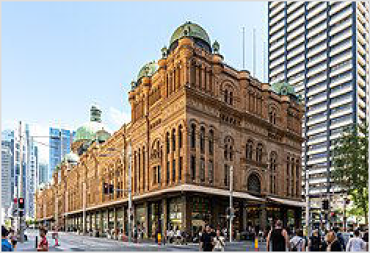Australian federation in 1901). A well preserved example of federation houses in Sydney is in the Inner West suburb of Burwood. Appian Way is a circular street built around a lawn tennis courts complete with pavilion house. The large houses are all architecturally unique and built on large expanses of land featuring old trees and lovely gardens. Further away on the lower North Shore, Castlecrag is a unique garden suburb, being planned by the architect Walter Burley Griffin in the 1930s.

Itineraries

The Queen Victoria Building (QVB) is an excellent example of British colonial influence on Australian architecture

Walking tour of Sydney - mainly around Central Sydney. Please see separate listing for detailed information.
One week in Sydney - some ideas on how to spend a week in and around Sydney, exploring different areas

Visitor information
Sydney Tourism (https://www.sydney.com/) website

Get in

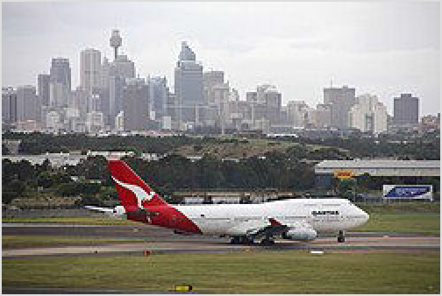By plane

Main article: Sydney Airport

Sydney Airport (https://www.sydneyairport.co m.au/) (SYD ^{IATA}) is Australia's busiest airport and the main gateway to eastern Australia. It is 9 km from the City centre in Southern Sydney on the northern shores of Botany Bay. Sydney Airport is the oldest continually operated commercial airport anywhere in the world. There are direct flights to Sydney from all the other

Sydney Airport with city skyline in background

inhabited continents, as well as some sight-seeing flights over Antarctica. The main ways to get into the city are by train (about $17 one-way on the Airport & East Hills line), or by taxi ($40-50 to the Rocks).

Western Sydney International Airport (https://www.wsiairport.com.au/) (WSI
^{IATA}) will open in October 2026. As the name suggests, it's in western Sydney, about 20 km from Penrith and 50 km from the city (a solid hour's drive in good traffic). Buses to key railway stations like Leppington, Liverpool and St Marys will be available, running every 30 minutes from 5AM to 10PM daily (the St Marys shuttle will be free). The M2 metro line is scheduled to open in 2027, connecting the airport and St Marys, with onward connections to the city by train.

For general aviation, it is advised to use Bankstown Airport (BWU ^{IATA}) or Camden Airport (CDU ^{IATA}), as they are less congested and far more accommodating to private planes than Sydney Airport.

By train
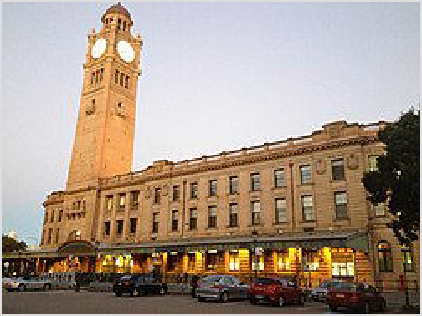Taking long distance trains from any other major city in Australia to Sydney is not a popular option, with flying or driving often being preferred for being faster and cheaper. Nevertheless Australia does have a functioning, albeit slow, network that may be worth considering if you are not in a hurry or want to get to some remote locations, and taking the NSW TrainLink sleeper services linking Sydney with Melbourne and Brisbane can be cost and time effective, by avoiding an extra hotel stay, and making the most of your days at either end. Unlike the Indian Pacific, these are not luxury trains, but part of the regular state run network, so fares are generally

Sydney Central Station
competitive with flying once taxes/fees and getting to and from the airport are factored in.

NSW TrainLink Regional (https://transportnsw.info) runs at least daily services to Sydney from Brisbane, Melbourne, Canberra and many regions of New South Wales including the Mid-North Coast, New England, the Central West and the Southern Highlands. It also services Broken Hill weekly. Travelling time from Melbourne and Brisbane is around 12 hours. Fares range between $50 and $120 for standard class seats and tickets should be purchased in advance either online or by phone. Tickets are only available from larger stations, though it's advisable to book online. The tracks in NSW are often slow and twisty, and generally travel by road is faster, though invariably more stressful, particularly on the Pacific Highway during the summer holidays, when Sydneysiders head up the coast in vast herds of SUVs and caravans.

One way to make efficient use of travel time is to use the NSW TrainLink sleeper services between Sydney, Brisbane and Melbourne. These leave every evening and allow you to save on a hotel stay at the other end, along with losing no days to travel. Sleeper cabins have two berths in a bunk layout (full bedding is included), and each has a hot shower, sink and toilet (shared between two adjacent cabins), as well as a buffet car with hot meals and a continental breakfast (which can be ordered to your cabin). Food is "no nonsense", affordable and perfectly fine, if not a gastronomic adventure. Regular seating cars are also available on overnight services, but are not recommended if you actually want a good nights sleep and arrive ready for a day of activities. Sleeper berths cost $234 (adult full fare - there are numerous concessions available so check when booking) and need to be booked by phone on 13 22 32 within Australia. Single occupancy is available if you purchase the second bunk.

The Indian Pacific (https://www.journeybeyondrail.com.au/indian-pacific/) (13 21 47 within Australia or +61 8 8213 4592 internationally) is a luxury train service run by private company Journey Beyond (formerly Great Southern) and runs from Perth to Sydney via Adelaide. Adult fares from Perth start from around $2,100 p.p. during the low season. Children get 20% off when travelling with an adult. Note that Journey Beyond has partnered with the Qantas frequent flyer program (https://www.qantas.com/au/en/frequent-flyer/partners/journe y-beyond.html), and it's possible to redeem Qantas points for reward seats on Journey Beyond

trains. The train departs from Perth on Wednesdays and arrives at Sydney on Saturdays. The train is more expensive than flights from Perth or Adelaide, and takes longer than driving yourself, so this journey is really for rail enthusiasts who want to see the interior of Australia at a leisurely pace while travelling in luxury. See Across Australia by train for more information.

All long distance (NSW TrainLink and Great Southern Railway) trains to Sydney terminate at Sydney's Central Station in the south of the CBD area. Travellers can transfer to Sydney Trains, light rail, city buses, and taxis. It is also easy to transfer to other long distance trains and coaches. There is short term metered parking so you can meet the trains on the platform. There are ATMs, a small choice of food outlets, cafes open until late, and a railway heritage society display and bookshop in the terminal.

NSW TrainLink Intercity (https://transportnsw.info) run fairly frequent services throughout the day from close regional areas: Newcastle and the Hunter Valley via the Central Coast, Goulburn via the Southern Highlands, Bomaderry via the Illawarra and Bathurst via the Blue Mountains. Intercity trains do not require a reservation, and the opal card is still valid. The core routes as far as Lithgow (Blue Mountains line), Newcastle (Central Coast line) and Kiama (South Coast / Illawarra line) run hourly or half hourly late into the night, and start early morning. Fares are very competitive, but onward bus connections from smaller stations are often very poor, especially in the Blue Mountains and parts of the Illawarra. Bikes are accepted on trains (but be considerate, especially around peak times and busy weekends), and can be a good solution to the onward travel problem. Core routes are all operated using double decker electric trains. Travel onto some of the outer lines requires a transfer to a (rather cramped) diesel railcar service. This is true for the Southern Highlands line (change at Campelltown), on the Illawarra/South Coast line for all stops south of Kiama, and for the Hunter Line (change at either Hamilton or Newcastle Interchange). The timetables are usually lined up fairly well to allow for easy interchange. Trains through to Bathurst are extremely irregular (2–3 a day), and most journeys require a change at Lithgow to a connecting bus service. There is no catering whatsoever on Intercity services, and that journeys can be up to three hours, even though the distance might seem short on the map, so bring food and drink with you.

By boat
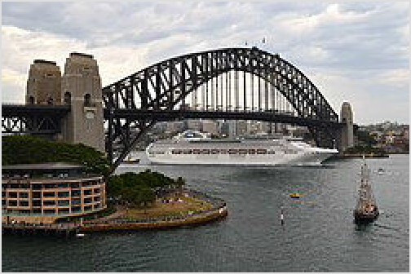Cruise ships visiting Sydney generally dock at the Overseas Passenger Terminal at Circular Quay or at the White Bay Cruise Terminal.

Circular Quay is a spectacular place to dock, right by the Harbour Bridge and across Sydney Cove from the Opera House, and you can walk off the ship into the city at The Rocks and then to the City Centre.

White Bay in the Inner West is not easy walking distance to anywhere. On cruise days there is a ferry (htt ps://www.captaincook.com.au/sydney-harbour-cruises/

Cruise ship sailing under Harbour Bridge

ferries/white-bay-cruise-terminal-city-ferry/) operating to Darling Harbour, as well as taxis and transfer services organised by the cruise companies (usually to the city and airport). Cruisers embarking from White Bay have a spectacular sail away, first going under the Harbour Bridge and then passing by the Opera House.

At peak times some cruises can be anchored off Taronga Zoo (Athol Buoy, west of Bradleys Head). If this happens to you, you will be tendered to Circular Quay passenger terminal to complete immigration, etc.

By bus
Coach companies operate to Sydney from all capital cities, and many New South Wales regional centres. The Sydney coach terminal is adjacent to Sydney Central train station in the City South. Follow the signs.

Coach travel to Sydney is usually quicker, cheaper and more frequent than train travel. Online and advance booking specials are usually available.

Greyhound Coaches (http://www.greyhound.com.au) has the most extensive bus network in Australia, but there are a few others.
Priors Scenic Express (http://www.priorsbus.com.au) operates a coach service from Parramatta, Liverpool and Campbelltown stations to the Southern Highlands, Kangaroo Valley and the South Coast
Local buses run from the Blue Mountains and Wollongong to Sydney’s borders. You may have to change buses to continue your journey.

By car
See also: Sydney to Melbourne by car and Sydney to Brisbane by car
It is around nine hours to drive from Melbourne or from Brisbane. If you're not used to driving long distances on boring roads, you may like to break up the trip over two or more days. Adelaide is around fifteen hours drive; it is usual to allow three days for the drive from Adelaide. The Hume Motorway/Highway between Sydney and Melbourne is a dual-carriageway high-quality road. The same applies for the Brisbane drive as well (except for two 12-km stretches). While it has high-quality sections, it also has two points that stick out like thumbs; Hexham and Coffs Harbour, and also carries high traffic volumes.

Melbourne–Sydney: 862 km via Albury-Wodonga (Hume Motorway/Highway/Freeway) (M31).
Adelaide–Sydney: 1422 km via Mildura (A20) or 1659 km via Broken Hill (A32) or 1377 km via Ouyen (A20/B12).
Brisbane–Sydney: 873 km via the coast (Pacific Highway/Motorway) (M1/A1) or 961 km via Armidale (New England Highway/Hunter Expressway/Cunningham Highway) (M15/A15). The Pacific Highway passes through more towns, attractions, and has more facilities compared with the New England Highway, but it can get congested moving through the towns around holiday times. Although the Pacific Highway route follows the coast, you won't see the ocean as the entire route is motorway standard. There are rivers all the way up the coast, and the river mouths are wide, causing the road bridges and the towns to be a little inland. If you have time, look for the tourist route diversions to see more of the Mid-North Coast and Northern Rivers on the way down (the beaches will be less crowded than Sydney!)
If you are renting a car, check the daily distance allowances and any one-way charge that may apply when driving from less popular destinations to major cities. Cars may be rented at the airport and elsewhere from major rental companies, or at smaller, less conveniently located, cheaper companies.

Ride-sharing can be arranged with other travellers. You can find a wide range of carpool offers on the Internet or in hostel noticeboards, etc. Usual warnings apply.

There are tolls applicable to most motorways in Sydney, but there are no toll gates where you can pay. See "Tolls" section below.

Get around

By public transport
The public transport system consists of train, metro, light rail, ferry, and bus services, and can get you virtually anywhere in the city as well as the outer regions. Public transportation in Sydney can be complicated, even when travelling solely in the CBD and inner suburbs. For short distances in the CBD it can be faster to walk than taking public transport.

Sydney transport symbols

Smartphone applications such as Google Maps, Citymapper, and TripView use live transit information for all modes of
transport are very useful for public transport trips within the Sydney region. Tripview is best for
a known route that you want the latest times. Moovit or Google Maps are best if you don't know the route, and need timing and stop-by-stop information. These apps are available on iOS and Android.

At all of Sydney's public transport stations/stops, you will see a lollipop sign with a single capitalised letter and a coloured background that indicates the type of transport service available. The sign "T" in orange means train, "M" in teal means metro, "L" in red means light rail, "F" in green means ferry, "B" in blue means bus, and "C" in purple means coach. Some bus stops also might say "T-way", referring to a name for bus rapid transit (BRT) lines.

Many train stations are easy access, with lifts to all platforms and ramps operated by station staff to allow wheelchair access to trains. All metro stations are fully accessible with lifts and level access between platforms and trains. All light rail stops are wheelchair accessible via an on-board ramp. Some ferries and buses have disabled access. Wheelchair friendly buses, stations, and routes are indicated on the timetable, and in the real time apps.

Fares
Sydney's public transport fare system is called Opal (https://transportnsw.info/tickets-op al/opal#/login). The fare system covers all train, metro, light rail, ferry and bus services in Sydney, Newcastle, Wollongong and the surrounding regions. There are three ways to pay for your journey:

Contactless credit or debit card. Visa, Mastercard or American Express is accepted, including those in a digital wallet like Apple Pay or Google Pay. All the same benefits apply to using a contactless card as apply to using an Opal card.
Opal card. A reloadable travel card that can be obtained at most newsagents and convenience stores or wherever you see the logo. The card costs $20 for adults and $10 for

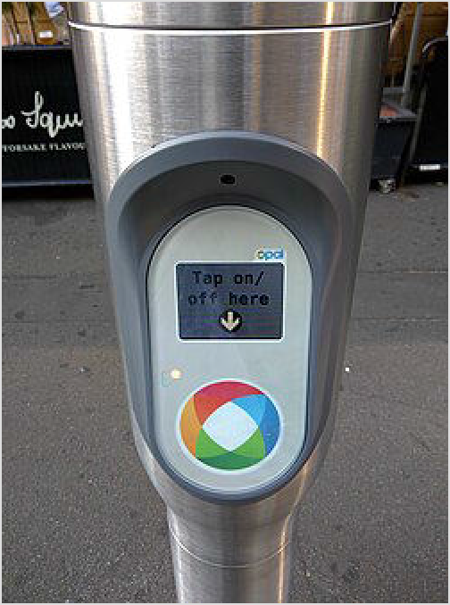children, the value of which can be used for travel. The card cannot be purchased at public transport stops (except the airport stations) unless the stop includes a retail outlet. Adding credit to an Opal card is known as 'topping up'. All Opal retailers provide top-up facilities. Top-up machines are available at most railway stations, some light rail stops, and all ferry wharves. All machines accept credit and debit cards (Visa/Mastercard with PIN), some also accept cash. You can also top up with a credit card on the web, or with the Opal app, but you must allow an hour before you travel to allow the top-up to reach the Opal card reader. The card can only be refunded to an Australian bank account. No refunds can be made by cash or credit card.
Opal card reader
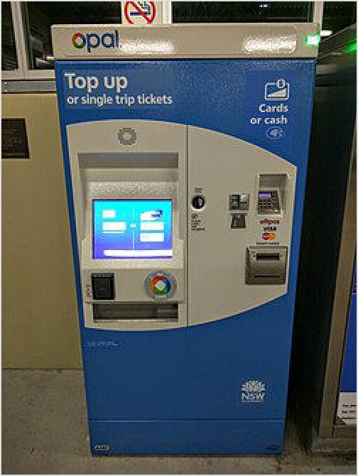Single trip tickets. You can obtain a single trip ticket at some top-up machines in train stations and ferry wharves. Tickets are 20% more expensive than a free reloadable Opal or contactless card and you get none of the caps and discounts that are on offer. You need to buy a ticket for every trip you make (i.e. you need to buy a second ticket at the start of a return journey), so these are best avoided unless you are making a limited number of trips.
Opal card machine
To travel, simply hold your card up to a reader to tap-on at the start of your trip, and tap-off at the end of your trip. This applies to all transport except for the Manly ferry, whereby you only need to tap-on. You must tap on before you board a train, metro, light rail, or ferry. Not all stations, stops and wharves have ticket barriers, so you'll need to remember to tap on or off at the readers or you'll be charged the maximum fare for your route. For buses, the readers are by the entry and exit doors. The readers on buses activate as you are approaching the stop, or soon after the bus has halted. You can check how much credit is remaining on your card every time you tap on or off, just look at the screens attached to the ticket barriers or readers. If you're using a contactless card you can check your fares online the following day.

Daily fares are capped at $18.70 from Monday to
Thursdays and $8.90 on Fridays, Saturdays and Sundays (June 2025). There is no need to worry about zone boundaries or having the right fare because the system will automatically calculate the fare for each trip. Other benefits include weekly caps, and off-peak discounts for trains, buses, and light rail (on Fridays, weekends, and between 10AM and 3PM/after 7PM on weekdays). No off-peak discounts apply for ferries. Any trip made within 1 hour of the previous trip is considered a continuation of a journey. No matter how much you travel, you will never be charged more than $50 in any Monday to Sunday week (not including the Airport Station access fees, and other OpalPay services). If you change modes of transport during your journey (e.g.

from train to bus) the system will provide a $2 discount on the fare of the second and subsequent trips. Children aged 15 years and under are entitled to a discount on most public transport. Children 3 years and under travel free.

By train
Sydney has a vast suburban rail network operated by Sydney Trains, covering 882 km of track and 176 stations. The train network will take passengers to most of the metropolitan area. Trains service every station in the metropolitan area at least every 30 minutes. Frequency is higher in the city, and major centres (Chatswood, Parramatta, Bondi Junction, the Airport, etc) usually see a train every 10 minutes or so. Peak times (7-9:30AM and 4:30-7PM) have more frequent and also crowded trains, as well as some express services that skip more stations. Expect congestion around Central and Town Hall.

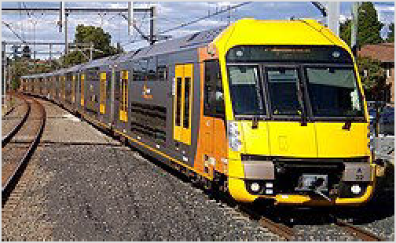You may get a clean modern train, comfortable seating and clear station announcements. Alternatively, you could get a train full of people packed in like sardines, with station announcements that are barely audible. Prepare yourself with your smartphone network map, just in case. All Sydney Trains are air-conditioned.

Most train services do not stop at every station and do not travel to the furthest extent of the line. Look at the departure screens at the station concourse which indicate when the next train will arrive, its destination, the platform it will depart from, and the stations it will

Sydney's iconic double-decker suburban trains

stop at. Alternatively, you can also listen to announcements that will regularly play before and when a train arrives at the platform. Or simply download an app that gives you platforms and times (with real time updates if you have mobile internet).

Outside of operating hours, between midnight (1AM on Fridays and Saturdays) and 5AM, NightRide buses run at least every hour. NightRide buses stop at most stations and a few additional stops, but they do not travel on the same routes. If you intend catching a NightRide bus home, check the NightRide route map. Buses can be crowded on Friday and Saturday nights.

Exercise caution whilst travelling on trains after 8PM, particularly if the carriage is mostly deserted and if travelling to western and south western Sydney, as it is not uncommon for undesirables to be found on trains during these times. 99% of the time they will not cause you any more trouble other than being loud, vulgar and obnoxious, but it is best to avoid them as unwanted altercations may follow. Moving to other carriages would be a good idea. The more modern trains have Emergency Help Points in every carriage, allowing contact with the train guard. Otherwise, travel in the middle carriages, near the guard's compartment (marked with a blue light). The guard has contact with police and the driver if there is any trouble on the train. Emergency Help Points are also available at every station.

Check for track work before leaving for the station; Sydney Trains shut down part of the network most weekends and will transfer passengers to buses if lines are closed. The process may add half an hour or more to a typical journey. Track work is usually on weekends or late at night on weekdays and the track work timetable is available on the Sydney trains website several months in advance (check before you leave home for the days you are visiting).

By metro
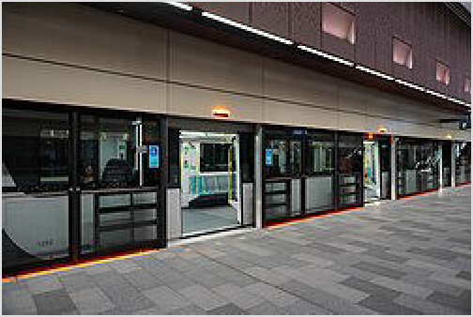As of 2025, Sydney Metro only has one line (M1), which runs from Tallawong in far northwestern Sydney through Chatswood, North Sydney, Barangaroo and Central. Services operate on automated driverless trains at a turn up and go frequency with similar operating hours to the rest of the rail network. Services are marked with a teal-coloured 'M' in a roundel at stations and on the rail network map. The line is integrated with the suburban train network and you can interchange between the services at Epping, Chatswood, Martin Place, Central and Sydenham stations.

Metro at Castle Hill

By light rail
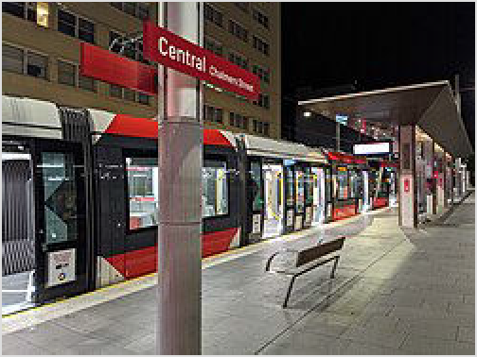There are four light rail lines operating in Sydney.

The L1 Dulwich Hill Line runs from Central to Dulwich Hill. This line is useful for travelling between Sydney City and western Darling Harbour, the casino, the Fish Markets, Pyrmont, and the Inner West. Be aware that the light rail to Darling Harbour and the Casino can get extremely crowded, even on Sundays. If you're only going a short distance (Central to Paddy's Market, for example), it'd be faster to walk instead. Beyond the casino is a spacious ride through the inner west.

Sydney light rail at Central Chalmers Street

The L2 Randwick Line runs down George St, connecting Circular Quay to Central, before continuing on to Surry Hills, Moore Park, and Randwick.
The L3 Kingsford Line branches off from the L2 at Moore Park and heads to Kingsford.

The L4 Westmead and Carlingford Line winds its way through the various hospital precincts in Westmead, past Parramatta CBD, before following the old Carlingford line to Carlingford.
Unlike buses, the Opal card readers are at the stops and not on the trams themselves, so don't forget to tap on and off before and after your ride.

By ferry
The Sydney Ferries central hub is at Circular Quay at the north edge of the CBD. Ferries run up the Parramatta River via Balmain and Olympic Park, around to Darling Harbour, across to Luna Park, across to Taronga Zoo, out to Manly, and out to Watsons Bay. They also go to Cockatoo Island. They run only within Sydney harbour, so you can't get a ferry to Bondi. Ferries run to most destinations at least every hour, with additional peak services, and half hourly services to Manly and Barangaroo/Pyrmont Bay.

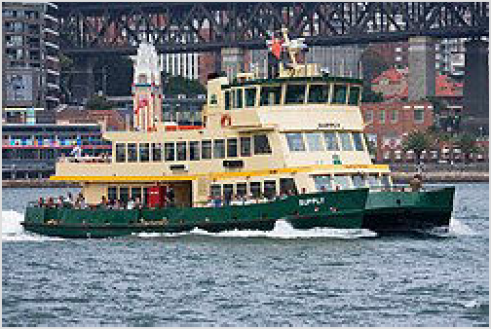At Circular Quay and Barangaroo, each wharf has a large screen showing ferry departures and general information. Find your destination on the screen, which shows when your ferry service is departing and from which wharf. Note that at Circular Quay, it will show the services for all nine lines, however, in Barangaroo, only
Sydney ferry
F3 , and F4 are shown.

More than just a utilitarian means of transport, ferries are a great way to view Sydney Harbour. The best ferry excursion for visitors is the F1 Circular Quay eastward to
Manly or, for a shorter and slightly cheaper trip, the F9 to Watsons Bay. Be prepared to take photographs of the Sydney Opera House and the Harbour Bridge as you leave Circular Quay. Ferries from Circular Quay westward to Balmain and Barangaroo offer great excuses to
experience sailing under the Harbour Bridge. The F2 Taronga Zoo ferry line is also an
experience for some, and offers a direct ferry line from Circular Quay to Taronga Zoo, the iconic zoo of Sydney.

The Manly and inner-harbour ( F1 , , , F7 ) ferries can get busy, but it is very rare that they
F5
F6
reach capacity. Opal offers half-price daily caps ($9.65 as of March 2026) on Fridays, Saturdays, Sundays and public holidays. This deal is popular, especially on sunny 'beach' days, with the viewing decks becoming tightly packed and the queuing chaotic. If you're only in Sydney a short time, then you may wish to spend the extra to travel on a weekday and avoid the associated hassles with crowds on popular days.

At peak periods, the F3 and F8 Parramatta River ferries can and do fill to capacity, and you should ensure that you have an alternative way for completing your trip. Passenger counts are strictly enforced and there is no effective queue, meaning that missing one ferry is no guarantee
you will get on the next. The main peak period is on sunny weekend afternoons returning from
Parramatta and all pickup points along the river, and during the Vivid festival heading towards the city. School holidays and weekdays 4PM–6PM at Barangaroo heading to Parramatta can be busy too (you are okay if you board at Circular Quay where the ferry originates) as commuters, tourists, and day trippers compete to get home. Cockatoo Island is an awkward place to be stuck, so allow enough time to get the ferry the other way and back if you need to.

Captain Cook Ferries and Manly Fast Ferries also run ferry services complementing and competing with the government-contracted Sydney Ferries. Manly Fast Ferries runs a service between Circular Quay and Manly. Captain Cook ferries run a Darling Harbour to Circular Quay, Barangaroo to Manly and services around the Harbour and to Harbour Islands. They also run a Zoo Express to Taronga Zoo wharf, with a combined entry pass the same price as the Sydney Ferries ferry. You'll get a nicer ferry and commentary on the way. They also run a Manly to Watsons Bay ferry that offers a significant time saving over the ferry via Circular Quay. For Manly Fast Ferries, you can tap your Opal Card or credit card to pay. Opal benefits (such as daily and weekly caps) are included.

By bus
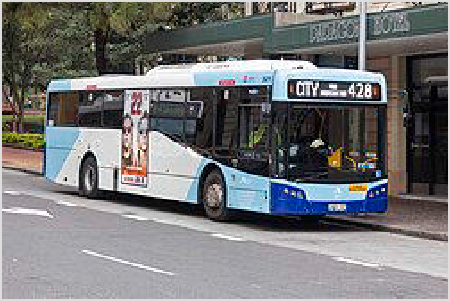Sydney has an extensive bus network. Some buses run from distant suburbs such as those on the Northern Beaches and North West all the way to the city, but there are also shorter feeders to suburban rail stations from surrounding suburbs.

A typical city bus in Sydney

It is a good idea to plan your bus trips in advance where possible. Transportnsw.info (https://www.transportnsw. info/) has a helpful trip planner feature to assist you, as well as route maps and schedules to print. Most bus stops have timetables posted, as well as a
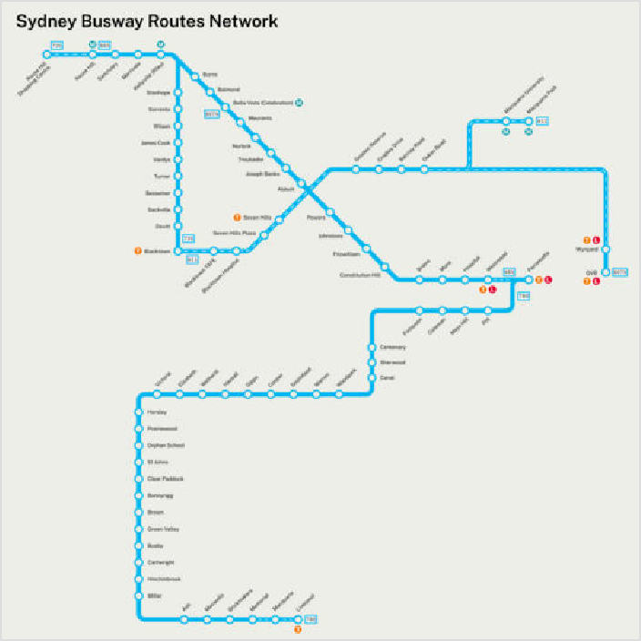route map for the routes servicing that bus stop.

You must flag down buses with an outstretched hand if you want them to stop for you and you must press the STOP button on board to disembark. They will not automatically stop unless they are signalled to do so.

On most buses there is nothing on the bus to tell you which stop you are approaching or which stop you are at. There are no poster maps on the bus either. If you're heading into unfamiliar territory, either take a paper timetable to track your route, or make sure you have an app downloaded to track your route and stops (Tripview/Moovit, etc). Also, if you take a bus marked "Limited Stops" or "Express" (often the route number may contain an E,

Map of bus routes that mostly use busways/T-way corridors.

L, M or an X), make sure that the bus stops where you want it to. Limited stops services stop only at major stops so they may make you walk around 750 metres or so if they skip your stop. However, express services can run very far from the city without stopping at all, before resuming a normal stopping pattern (express buses only operate during peak hours). All normally numbered buses stop at all stops, so missing your stop or getting off one stop early is a less serious mistake. Route numbers starting with M are longer route, cross city buses, running at 10- to 20-minute frequencies during their operational hours.
There are two main bus termination points in the CBD, at Wynyard and Circular Quay. These two points are separated by a one-stop commuter train trip. You will need to make this trip if connecting from buses arriving from north of the Harbour Bridge to buses heading east or west, or vice versa. There are bus information centres at Wynyard and Circular Quay. During peak hours some buses from the south and west terminate at Town Hall to avoid congestion in the CBD.

All buses are GPS-equipped, so you can use an app like TripView, Google Maps or Citymapper to track arrival times in real time. There are few transport apps available that indicate from 0 to 3 how crowded a bus is. If you want to go a long distance and can see the next bus is full, you can consider waiting for the next one.

A few trunk routes run to the Eastern Suburbs and to Newtown 24 hours a day. Additional services operate late Friday and Saturday night to the Northern Beaches and to the North West.

By boat
Charter a boat on the Harbour to get you across the water. Lots of services are available around the Harbour, with self-drive boat hire (https://eastsail.com.au/self-drive-boat-hire/), luxury boat hire and more. Around New Years Eve, and Australia day the Harbour is at its busiest so take care to organise ahead of time.

By taxi
Taxis in Sydney are expensive and notorious for various scams and ripoffs, ranging from mysteriously broken meters to fictitious surcharges and scenic detours, but they can also be the only transport option available to some locations late at night when the trains and regular buses stop. It is almost always faster, cheaper and more convenient to use rideshare services instead.

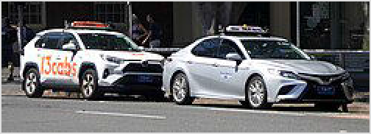Taxis in Sydney (13CABs and Silver Service)

There are numerous operators. 13cabs (https://www.13cabs.com.au/) is the largest and offers an Uber-style app with tracking and fixed fares. You can also hail cabs off the street: if the light is on, it is available for hire; if the light is off, the cab is occupied. By law, taxi drivers have to take you where you want to go, regardless of your destination, but particularly at busy times like Friday evenings many will refuse rides in the "wrong" direction.

There are two meter rates: a day rate (rate 1) with a flag fall of $3.30, a distance rate of
$1.99/km, a "waiting" rate of $0.85/min, and a booking fee of $2.50; and a night rate (rate 2 – applicable to journeys commenced between 10PM–6AM), which adds a 20% surcharge to the distance rate. You can check the rate your taxi is using by looking for a 1 or a 2 next to the current charge: if it is set to 2, it is using the night rate. The so called "waiting" rate is charged whenever the speed drops below 25 km/h. For trips in congested traffic, it is possible for large parts of the trip to be charged at the "waiting" rate. All Sydney taxis are metered and taxi drivers hailed at the kerb are supposed to charge the metered rate, with any charges for tolls added automatically during the journey.

Passengers are required to pay all tolls for their trip. Drivers will usually take the toll roads unless you ask them not to, and with some tolls approaching $10 a pop, this can get expensive fast. Tolls are added automatically by the meter as incurred during the journey.

Taxis accept all major credit cards, although credit card terminals are improbably often "broken". They charge an extra 5% on top of the fare for this. Many of the taxi companies have their own apps. Tipping is not required or generally expected. However, rounding up a taxi fare

to the next dollar (or five or ten dollars, depending on the base fare) is fairly common. On the other hand, if the driver rounds the fare down to the nearest dollar, accept with grace.

If you need a child seat, a wheelchair taxi or are traveling with a large group, you can call ahead for maxicab, which can fit up to 10 people. The airport has a maxicab rank.

Scams such as taxi drivers refusing fares, deliberately not using a meter or overcharging is illegal but rife and scams are known to affect both local Sydneysiders and visitors. If you have been scammed, immediately file a report at pointtopoint.nsw.gov.au (https://www.pointtopoint.
nsw.gov.au/contact-us) or contact ☏ 131 727 (domestic). It's likely you will get a portion of your
fare refunded. Make sure you take as many photos documenting your experience if it is safe to do so; also try to get the taxi driver's ID and license plate if possible.

By rideshare
Uber and Didi offer a convenient alternative to taxis (Lyft isn't available in Sydney), and considerable cost savings when there is no surge, with Uber somewhat more expensive than its competitors. Ubers will nearly always take the fastest route (including tolls when necessary) unless you tell them to take another way. They are every bit as common as taxis in the city and most suburbs, and for most travelers, there's little if any reason to ever take a taxi; the main exception is if you have children under 7, who cannot legally ride without a child seat (which rideshare companies rarely if ever offer). Rideshare drivers also cannot legally use bus lanes, while taxis can.

By car
If you are spending time in the CBD, and visiting near-by attractions like Manly, Bondi (and the Eastern suburbs), Pyrmont or the Inner West, then a car may be more hassle than it's worth, with congestion, complex one-way schemes, and expensive and time-restricted parking. However if you are keen to explore the northern beaches, outer suburbs or travel further afield, a car may be the best option for travelling. Check the daily distance allowances and any one-way charge that may apply when driving from less popular destinations to major cities. Cars may be rented at the airport and elsewhere from major rental companies or at smaller, cheaper companies.

Sydney traffic is always busy, but outside of peak weekday times travelling by car is usually at least as quick as any method of public transport. Congestion can be expected on roads to the city 6:30AM-9:30AM, and roads away from the city 4:30PM-6:30PM. Allow double the normal travel time during these periods - longer if you are using motorways. Congestion is considerably worse and longer in both directions during the Friday afternoon peak. Some roads experience congestion at other times and roads heading to shopping, sports, parks and beaches can be heavily congested on weekends also - particularly on Saturday mornings and Saturday evenings. Roads around Bondi Beach and the other eastern suburbs beaches experience gridlock on summer weekends, with buses often caught in the same traffic as cars. Travel times from the city centre to the Sydney outskirts can take around 45 minutes in good traffic.

Roads are generally well signposted to the next major suburb or suburbs along the route, and all (except freeways) have road names. A handful of cross-city roads are signposted by alphanumeric code. The airport is signposted from many major routes with an aeroplane symbol.

Tolls
Some motorways, tunnels and bridges charge tolls between $2 and $8 depending on the road and distance. There is no logic behind which ones charge and which ones don't - the reasons are all historical and political. Toll roads are indicated by the word TOLL or TOLL E-e on the signboard when joining the road. Tolls are charged on the:

M1/A4 Harbour Bridge and Tunnel (southbound) M1 Eastern Distributor (northbound only)
M2 Hills Motorway M2 Lane Cove Tunnel Cross City Tunnel WestLink M7
M5 South-Western Motorway east of Liverpool
M5 East (note that the toll is different from the M5 South-Western Motorway), east of Beverly Hills to Brighton-le-Sands
M4 Western Motorway (east of Church Street), including the M4–M8 link Westconnex M8, including the M4–M8 link
M11 Northconnex
A8 Falcon Street entrance to the M1 Warringah Freeway northbound
If you want to plan a toll-free route, you can avoid the Cross City Tunnel, M2, M4, M5, M7, M8 or A8 Falcon Street on-ramp fairly easily. However, it is hard to avoid the harbour crossings if you are going to the CBD from Manly, the Northern Beaches or the zoo by car. If you're using a GPS check the toll-free routes, because outside of peak some toll roads offer little time saving.

All rental cars come with a way to pay tolls. They each charge their own service fees that can be a daily flat fee, or an administration fee and tolls. Some rental car companies register the licence plate, so you have no option other than to use their toll service.

If you are managing the tolls yourself you need to have a pass or a tag.

A pass (also called an e-pass) is the simplest way to pay tolls. You can pay with a pass up to 48 hours after your travel on a tollway. Depending on the provider, you can register your licence plate on the website, or you can download an app and pay as you travel. Pass providers charge additional fees on top of the actual toll. All provider passes work on all toll roads - pick the one that works for you.
A tag (also called an E-tag) is a transponder stuck to the inside of your windscreen. This may involve an upfront payment or deposit and/or monthly fees. You will also need to apply and have the tag posted to you in advance of travel. The advantage is that there is often no surcharge applied to the actual toll itself, so it would likely only make sense for extended stays.
The Sydney Motorways (https://roads-waterways.transport.nsw.gov.au/sydney-motorways/toll- calculator/index.html) website provides links to all tag and pass providers.
Not paying a toll within three days of driving on a toll road will incur a $15 administration fee in addition to the toll. If you are in a rental car, the rental car company will charge an additional fee for this to your credit card.

Parking
Parking in and around the city requires some consideration. Much of the available parking space in Sydney's centre and suburbs is time limited, and fees can apply.
Parking your car in the City Centre in parking stations is always possible but can be very expensive if you don't plan properly. Expect to pay up to $90 for three hours at some central parking lots if you just drive up. Prices generally reduce significantly on weekends however with some car parks charging $15-20 flat fee for full day parking. Reduced parking charges are also made on weekdays for early-bird parking, where you must enter and leave within prescribed times. For example you can park all day at the Opera House (http://www.wilsonparking.com.au/ go/wilson-car-parks/nsw/sydney-opera-house) for $16 as long as you enter before 10AM and leave 3PM-7PM. There is no grace period, so you cannot get out even one minute before 3PM, and you will be charged the day parking rate of $42 if you are 10 seconds late. Most city parking lots offer reduced flat fees (around $15-$25) for evening and weekend parking. Booking parking online in advance can offer dramatic savings, with offers as low as $10 for all day parking sometimes available.
Street parking in the CBD is generally only possible before 8AM and after 6:30PM on weekdays and, even then, is almost invariably metered until 10PM at $2.20-3.30 per hour. On weekends, most parking spaces have a 4 hour limit, again metered at $1.10-2.20 per hour. All day street spots are sometimes available in the Domain/Mrs Macquarie's Chair and Hickson Road, but these spots are often taken up by commuters, and, since they are metered, an early bird deal may work out cheaper than the metered rate. Parking meters accept credit card payment. Similar prices are charged in North Sydney.

City hotels invariably charge for parking for the guests.

Parking in many major suburban centres and beaches can be a matter of spending time cruising and searching for parking spots. Usually parking within easy walking distance of these centres has a time limit restriction - often 2-3 hours. Shopping centre car parks usually have a similar restriction, with fees applying after an initial free period.

Some train stations have all day free commuter parking. At major stations, this can be full before 8AM. Smaller stations with less frequent train service tend to have better parking availability. On weekends it is easy to find a spot in the commuter parking lots. The stations with commuter parking are marked on the Sydney Trains maps.

Parking at some beaches, on summer weekends, can often be almost impossible. Some beaches are in suburban neighbourhoods, without large car parking facilities. Check the appropriate destination guides for more information.

Parking fines in Sydney are $108 if you exceed the allowed parking time or don't pay the fee in a legitimate parking space. Reloading the meter or moving your car within the same parking zone will not get you out of a fine. Parking in a no stopping zone will cost you over $200 (indicated by signs or a solid yellow line near the kerb). If you park illegally and wait with your car, you may find you have the licence place photographed and fined before you have the chance to move on - don't expect a warning. If you park illegally in a disabled spot, the fine is $541. If you do get fined for exceeding time, you will not be fined again the same day so you might as well enjoy your parking spot.

Clearways are no-stopping zones on main roads during peak periods, marked with clearway signs and a broken yellow line on the kerb. Fines will be around $400 to reclaim your car after it is towed away. Clearways also offer parking opportunities if you want to park just after 10AM.

Speeds
Speed limits can change frequently, even on the same road. Speed limits drop for areas of pedestrian activity, schools (40 km/h or 30 km/h 8AM-9:30AM and 2:30PM-4PM on school days), roadwork, as well as driving conditions. Some roads have variable speed limits that change during busy traffic times. Every road in Sydney has a signposted speed limit and the only way to be sure of the limit is to pay attention to the signs. You cannot tell the speed limit just by looking at the road. The speed limit is usually 50 km/h on residential streets, 60 km/h to 100 km/h on main roads, and sometimes higher on motorway sections with a max at 110km/h.

Speed limits are extensively enforced, and penalties are severe. Enforcement is mainly by fixed speed cameras, but also by mobile speed cameras (from a speed-camera equipped vehicle parked at the roadside), hand-operated speed "guns" operated by police, and by police highway patrol cars. Speed cameras are installed at many traffic-light controlled intersections, and these cameras also enforce the "stop at red lights" by taking two pictures, the first of the car crossing the stop line (painted on the road) while the light is at red, and the second as the car passes through the intersection (thus proving that it was not simply a case of the car stopping a metre or so past the stop line).

By bike
See also: Cycling in New South Wales
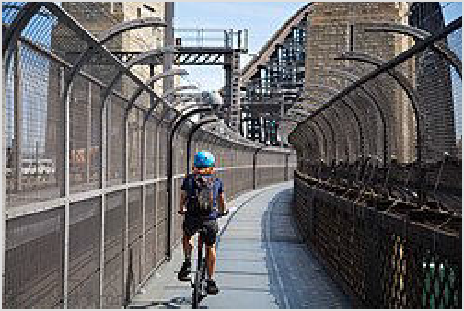If you are a fit and experienced urban cyclist, used to riding on multi-lane roads in heavy traffic, then just get on your bike. Cyclists are permitted just about everywhere on Sydney's roads, except for some freeway tunnels where bicycle signs will usually direct you to the alternative route. Kerbside lanes are often narrow, so ride assertively, be seen, and take the full lane when you know there is insufficient room to be passed. Bikes are permitted in bus lanes (like the city streets), but not bus only lanes (like the Harbour Bridge, and T-ways).

A cyclist on Sydney Harbour Bridge

The city centre is not particularly cyclist friendly traffic-wise. It is not flat either - you can expect regular hills but no marathon uphill climbs. The weather is, however, usually good for cycling.
If you are looking for a quieter ride, a number of quiet on-road and shared pedestrian/cycle paths are available, but can be hard to find. A good place to start is at Sydney Olympic Park where you can get your cycle legs on the extensive off-road trails; then, if you want to, you can follow the Parramatta River to Parramatta or following the Cooks River to Botany Bay in Southern Sydney. The Harbour Bridge has a dedicated cycle lane, suitable for all ages, but as soon as you get off the bridge (and down the steps!) you are back onto urban streets in Milsons Point.

The Bourke St cycleway is a north–south route in the City East and a cruisy place to cycle between Woolloomooloo, Darlinghurst and Surry Hills. Lots of shade and cafes to break the trip. Some other separated cycleways have opened in the CBD, but they are yet to form a cohesive network, and your trip may easily end up on a busy and unforgiving city road if you haven't planned well in advance.

Other cycleways are often just converted footpaths, so be on the lookout for bollards, street signs, roots and branches strategically placed across cycle paths - as well as pedestrians. If cycling at night ensure you have lights bright enough to light your path.

It is illegal to ride bicycles on footpaths unless cycling with children under 12. In reality this is fairly weakly enforced out in the suburbs, but it is common for people to be fined for cycling through pedestrian malls in the city like Pitt St Mall or Martin Place. Out in the suburbs you can often follow quiet streets, and hop onto the footpath for a short stretch if things get too hairy. Bicycle helmets are required by law, as are lights and reflectors at night.

Bicycles can be taken on all trains, ferries and the metro for no cost. But catching a train in the CBD or close to the city in the peak may mean waiting for several services to find one you will fit. Check trackwork schedules on weekends (http://www.sydneytrains.info/service_updates/track work/), when buses replace trains and make taking bicycles more challenging.

Sydney centre now has Mobike dockless bike share scheme (https://mobike.com/au/) and Lime e-bikes if you don't feel like you've got your hill-legs. Simply download the app, pay a refundable deposit, and you can grab your closest bike. Park it anywhere you like. Longer term bike hire is available in many locations in Sydney. Unfortunately, bike hire for two bikes for a day usually costs more than hiring a small car and petrol for the day (around $50 per bike). However, for shorter periods some places may be reasonably priced (for example Sydney Olympic Park) charges $15 per hour. Also, you have to consider the additional cost if the bikes are stolen or damaged. However, they are much easier to park, are greener and can be more fun. See the district articles for bike hire listings.

If you want to join in a longer ride, most bicycle user groups around Sydney organise weekend rides for various levels of fitness. There is usually no charge to join in.

By foot
Sydney is quite pedestrian friendly, and as always you will see a lot more when moving around on foot than by wheels. On sunny days a long sleeved shirt, sunglasses, sunscreen and maybe even a hat is advisable. It takes some 45 minutes to walk from Central Station up through the CBD to the Opera House. For details on a self guided walking tour in Central Sydney, see Walking tour of Sydney. Even some more distant destinations are walkable if you have the time, fitness and inclination. It's less than 2 hours to walk through the exclusive eastern suburbs to Bondi Beach, or south through part industrial, part hipster Alexandria to the airport.

See

See also: Sydney with children

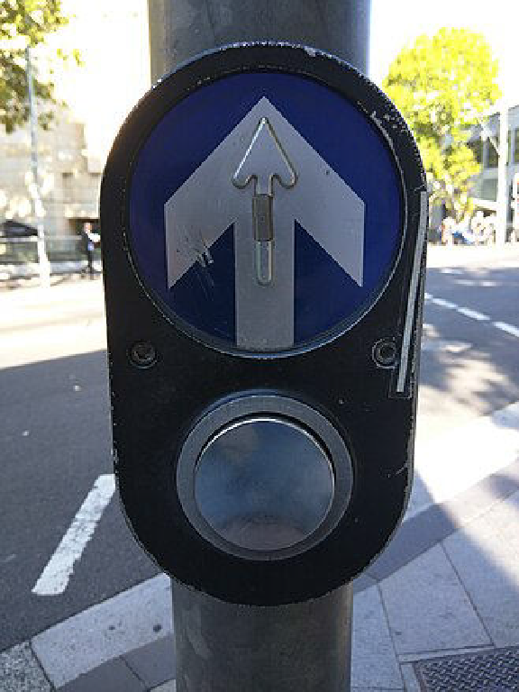Most of the Sydney landmarks can be seen in the City Centre with the iconic Sydney Opera House as well as visiting the Art Gallery of New South Wales, Sydney Tower, St Mary's Cathedral, Royal Botanic Gardens and the State Library of New South Wales.

Pedestrian signal push button in Sydney.
Right next to the centre is the historic district of The Rocks where you see Sydney's heritage as well as walk across the Sydney Harbour Bridge.

Darling Harbour is west of the City Centre and offers plenty of attractions such as the National Maritime Museum, Sydney Fish Market, Sydney Wildlife World, Sydney Aquarium and the Powerhouse Museum.

Cross the Harbour Bridge to reach the Lower North Shore where you can visit Luna Park. Taronga Zoo can be reached by a dedicated ferry from Circular Quay.

Take the ferry further out to Manly where you can visit the famous beach and walk to Middle Head passes many coastal artillery fortifications built into the cliffs of Sydney Harbour during the late nineteenth century.
Visitor Passes
You can buy one and two day unlimited access passes to a range of sights and activities. There is also a "Sydney Attraction Pass (http://www.syd neyaquarium.com.au/news/syd ney-attraction-pass-offer/)" with five venues including Sydney wildlife and sealife (Darling Harbour), Sydney Tower and Madame Tussaud's. You have 30 days to visit (one pass per venue).

Head out in the sun to visit the Eastern Suburbs where you can find the world famous Bondi beach, as well as many other beaches and La Perouse.

Sydney offers many opportunities to discover indigenous heritage, with rock carvings, dancing and art galleries to explore.

Sydney is known for its dozens of vibrant suburbs, which reflect upon the beauty and diversity of the city all because of its character.

Sydney Harbour
Sydney's world-famous beauty is defined by Sydney Harbour that can be easily viewed from the city and many areas around it. The large natural harbour was the reason that the original penal settlement was established in the area, near what is now known as Circular Quay.

An excellent way to see both the harbour and Sydney attractions is to take any ferry from Circular Quay. These are very reasonably priced and a favourite with tourists who can see most of the harbour from the various routes offered. Heading to Manly on the ferry makes for a great 30 minute trip at a fraction of the price of a commercial harbour cruise.

The world famous Sydney to Hobart Yacht Race begins every year on Boxing Day, on Sydney Harbour. Thousands of spectator craft take to the water to farewell the yachts as they set off on their gruelling journey to Hobart. Seaworthy craft can follow the yachts through the Sydney Heads into the open ocean. You can also see the race from a harbour vantage point like Watsons Bay. where you can see them sail towards you across the harbour, and then cross to the gap to see them sail down the coast.

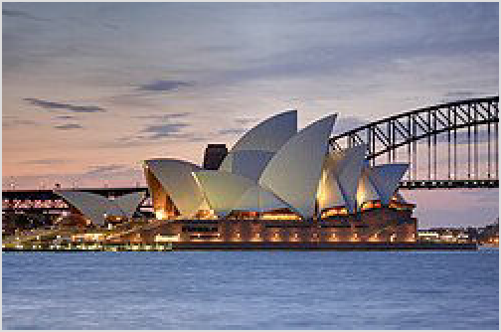Harbour Bridge hiding behind the Opera House

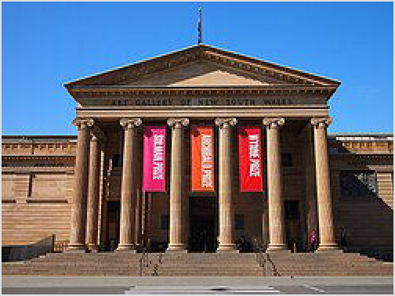Do

Art gallery of New South Wales

See also: Sydney with children

Beaches
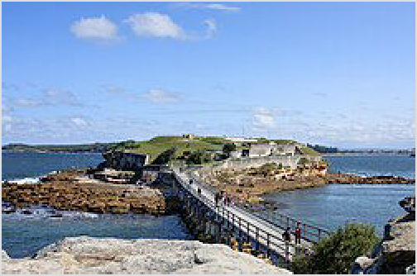Sydney's beaches are the perfect place to spend a warm summer day, where you can swim or lie on the sands to your heart's content. The most popular are Bondi, Manly, Cronulla and Coogee, although many others have their own charms. They might not be miles of golden beaches like Queensland, but there's a great variety, ranging from ocean beaches nestled between towering headlands in the Eastern Suburbs to quiet bays facing the harbour in Mosman. Bondi and Coogee are backpacker haunts while Manly and Cronulla feel like separate seaside towns. Soak in the crowded atmosphere amongst the other sunseekers in the eastern beaches, or be one of the few enjoying the solitude in the Northern Beaches and the Royal National Park. Brave the ocean waves, or splash about in the shallower rock pools. Even in winter, you can join the hardy souls keeping to their exercise regime in the cold waters.
Wildlife
Sydney also offers opportunities to see wild Australian animals

Whale Watching see whales migrating the Pacific coast.
There are boats from Darling Harbour or Circular Quay.
Bats (Flying foxes) nest next to the fernery in the Botanic Gardens in the city, and fly to feed over the city buildings and Harbour Bridge at dusk, you can see them on the eastern side of the Opera House at sunset.
La Perouse

Surf at one of Sydney's many surf beaches, a quintessentially Australian experience. The major beaches (Bondi, Manly, Cronulla) have surf schools and places where you can rent surfboards. Locals have their own secret favourites in the Northern Beaches and Maroubra, and can be fiercely territorial.

Kayak and canoe
Sydney's waterways offer great canoeing and kayaking, and you can explore Sydney's bushland, history, and exclusive waterfront properties. There are lots of places to hire them from, or to even go on a guided tour.

The Spit or Manly to kayak the harbour.
Rainbow Lorikeets swarm around the trees in many suburbs at dusk, making a tremendous chatter.
Sulphur Crested Cockatoos are commonly seen and heard in the leafier suburbs all day: pure white with a yellow crest, they're beautiful to look at, but have a startlingly loud shrieking call.
The White Ibis may be an ancient symbol of royalty in Egypt, but its Sydney cousin has adapted to city life so well it's known as the bin chicken for its penchant for using its long, curved beak to dig around in garbage bins. Ubiquitous in Hyde Park and the Botanic Gardens.
Possums are a native marsupial at home in the urban environment. Look up carefully in tree lined streets, or in Hyde Park after dark. Locals regard these critters as somewhat of a nuisance as they have a habit of nesting in the warmth of house roofs and love to brawl noisily at about 2am above your bedroom.
Kangaroos, Wallabies, and Rosellas. These can sometimes be spotted with patience in most of the Sydney National Parks, including at the Basin in Kuringai National Park, ask the local rangers where they tend to be seen in the late afternoons. This is a great way to experience Australia’s native wildlife in their natural habitat compared to seeing these amazing animals confined in zoos, but requires considerably more time and patience.
Lane Cove National Park and the Royal National Park have canoes and kayaks by the hour - see turtles and birdlife as you paddle
You can paddle on the Georges River from Woronora, or the Port Hacking river from Bundeena.
You can hire canoes at Rose Bay, a little bit east of the city.
You can also hire a canoe and have a BBQ at Lake Parramatta; 15-30 minutes by car from Parramatta.

Fish
Sydney offers decent fishing although it is not recommended to fish in Sydney Harbour to the west of the Harbour Bridge due to pollution and the fish are tainted with dioxin which is harmful to humans. You will nevertheless see local residents fishing on the harbour. You can sign up with a fishing charter to take you out of the Harbour into open water, Middle Harbour or Pittwater is a rewarding experience. You'll likely catch something of decent size and even if you don't, being out on a boat in Sydney is one of the great Sydney experiences in the warmer months.

Walk
Sydney has a huge amount of green space, much of it beside the sparkling harbour or ocean, so walking is a great way to experience the city's parks, reserves and remnant bushland. There are also great walks through
the more built-up areas, allowing you to check out the city's modern architecture and its colonial heritage. The following are just a few of the better-known routes.
Circular Quay and surrounds. Start underneath the Sydney Harbour Bridge, then walk with the harbour waters on your left, down through The Rocks, across Circular Quay, up to and around the Sydney Opera House, down through the Royal
Botanic Gardens, and up to the magnificent view of the Opera House and the Harbour Bridge at Mrs Macquarie's Chair. Some variation of this spectacular walk is, for many, the epitome of the Sydney experience. For detailed information about a walking tour of the city centre, covering these sights (in the opposite direction) and other major sights, see Walking tour of Sydney.
Across the Harbour Bridge from The Rocks on the south side to Milsons Point on the north side (or vice versa).
Coogee Beach to Bondi. Following the eastern coastline past several of Sydney's beautiful beaches - stop off for a swim if you get too hot.
Manly to Spit Bridge Walk (http://www.manlyaustralia.com.au/information/what_to_do/ walks/walkway.asp). Along the foreshore of Sydney Harbour.

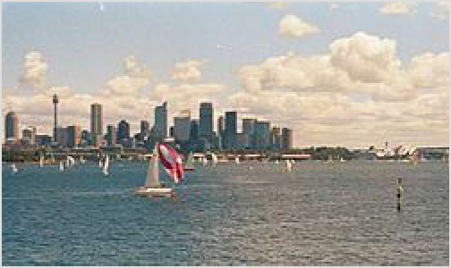1 Bradleys Head. Take the ferry to Taronga Zoo wharf and then head to your right along the promontory. There's pristine bushland (almost unchanged from the time of European colonisation), quiet beaches, and knockout views across the harbour, and in the warmer months you'll spot plenty of Eastern Water Dragons, a type of large lizard.
Once you reach the tip of the headland, you can either amble back to the wharf or - if you're feeling more ambitious - follow the track several more kilometres to Clifton Gardens, ogling the gigantic houses along the way. From there, you can either hike all the way back to Taronga or get a bus to a ferry wharf.
For quieter trails with a rural feel, the best choices would either be Ku-ring-gai Chase National Park or Garigal National Park, both which are not too far away from Sydney CBD.

Yachts in Sydney Harbour; business district in background

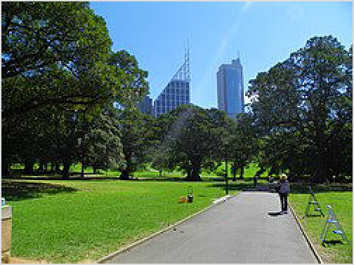Sports fixtures

Rugby/Footy in Winter
The winter rugby football season generally begins with trial matches in February, before the season proper kicks

Walk through the Royal Botanic Gardens

off in March and runs to late September or early October. Sydney's most popular football code is rugby league (often just called 'football' or 'footy' by locals — although never just 'rugby', which refers to rugby union). Nine teams from the national competition (http://www.nrl.com) are based in Sydney and the sport is an important part of the city's culture - many teams play at least some of their games at intimate grounds in their suburban heartlands, and this can be a good way to experience the traditional heart of the sport.

Cricket in Summer
Sydney's primary summer sport is cricket, which you'll find being played (in somewhat modified form) on beaches and in backyards across the city. The professional stuff is largely based at the Sydney Cricket Ground close to the CBD: the traditional New Year's Test, between the Australian team and whichever foreign team is touring at the time, commences around the 3rd of January and runs for four to five days. Later in the summer, international one-day and/or Twenty20 matches are held at the SCG. The primary domestic tournaments, contested between Australian state teams, are the Sheffield Shield (first-class), Ford Ranger Cup (one-day) and is the home ground for Sydney Thunder and Sydney Sixers in KFC Big Bash (Twenty20): they are usually sparsely attended and so are much cheaper to attend than internationals. Some one-day and Twenty20 matches are played at ANZ Stadium at Olympic Park rather than at the SCG, but the cavernous stadium is far inferior to the grand old ground if you really want to get a feel for cricket culture.

Bike and skate
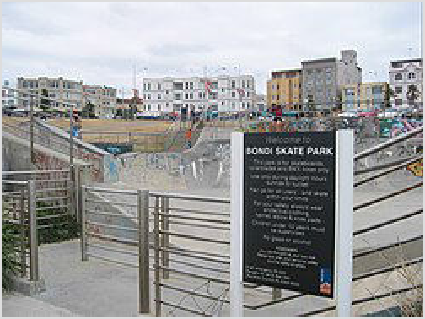Cycle around Centennial Park in the Eastern Suburbs or Bicentennial Park at Sydney Olympic Park. Or mountain bike on the challenging hills around the parks, forests and waterways surrounding Sydney and through some spectacular countryside.

Bondi skate park

Sydney has many skate parks and bowls in its suburbs, and one of the most popular is the one next to Bondi Beach. Sydney has ice skating centres, with the Macquarie Ice Rink (https://www.macquarieicerink.co m.au/) in the Macquarie Park-Ryde area. Canterbury Olympic Icerink (https://www.canterburyolympicicerin k.org.au/) is closed and being renovated (Feb 2024).

Performing arts

Stage
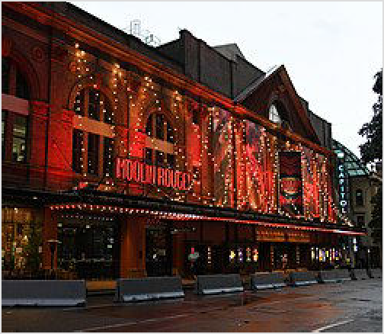Sydney has three major commercial theatres which show the big international musical productions, the Capitol Theatre in Haymarket, the Theatre Royal under the MLC Centre in the CBD and the Lyric Theatre in The Star casino complex at Pyrmont Bay.
Capitol Theatre

The Sydney Theatre Company (artistically directed until 2013 by Cate Blanchett and now by her husband Andrew Upton) is the biggest professional theatre company in the city. It produces a large annual program using The Sydney Theatre and the two Wharf Theatres in Walsh Bay in The Rocks and sometimes the Sydney Opera House Drama Theatre as well.

The Belvoir St Theatre in Surry Hills in City East has long been the smaller cousin to the Sydney Theatre Company, a place where young actors and directors cut their teeth in the associated Company B troupe before going on to bigger things. It stages a number of plays every year and you can wander the foyer before the show and see how many Hollywood names you can pick out from the old production posters.

The Ensemble Theatre at Kirribilli in the Lower North Shore (just over the Harbour Bridge) is Sydney's oldest surviving professional company and also produces a full program of plays every year, often featuring Australia's locally famous thespians.

There are also a number of small drama theatres with companies in Sydney including the New Theatre in Newtown in the Inner West, the Griffin Theatre Company at the SBW Stables Theatre in Kings Cross in City East and the Darlinghurst Theatre in Potts Point in City East.

The Seymour Centre (part of Sydney University just off Broadway on City Road) is a complex of several medium sized theatres hired by many independent and touring productions through the year. It is also the home of the University Revues, usually around August to September, a series of comedy sketch and musical shows put on by the students of each faculty in the University. Sometimes a place to spot future talent, famous past writers and performers in the reviews have included Clive James and Germaine Greer.
Amateur theatre, especially musical theatre, proliferates in Sydney, with over 30 amateur musical theatre companies providing a fun night of theatre for around $20 per ticket out in the suburbs. Check the Riverside Theatre in Parramatta, the Zenith Theatre in Chatswood on the Lower North Shore, the Sutherland Entertainment Centre in Sutherland and the Glen Street Theatre in Belrose in the Northern Beaches. Most of these theatres also feature occasional travelling professional productions.

Classical Music
For classical music fans, the Sydney Symphony Orchestra produces a large annual season and plays primarily at the Sydney Opera House Concert Hall (http://www.sydneysymphony.co m) but sometimes also at the Angel Place Recital Hall (http://www.cityrecitalhall.com).

The Australian Chamber Orchestra also produces a large annual program, mostly at the Angel Place Recital Hall but sometimes also at the Sydney Opera House.
The Sydney Conservatorium of Music in Macquarie Street often hosts performances on a smaller scale in the Verbruggen Hall within the conservatorium (https://www.sydney.edu.au/m usic/).

If you're in Sydney in the summer month of January look out for the major outdoor concerts held by both the Sydney Symphony Orchestra and Opera Australia in The Domain as part of the annual Sydney Festival. These free concerts are often attended by over 60,000 people.

Opera
Opera Australia, the national Opera company based in Sydney, performs an annual season at the Sydney Opera House in the City Centre.

Ballet
The Australian Ballet is the Australian national ballet company. Although based in Melbourne it splits its annual season between that city and the Sydney Opera House.

Jazz
The Basement nightclub near Circular Quay is Sydney's oldest and most pre-eminent jazz venue. It features other styles of music as well but has a reputation as the place all the big jazz acts perform when they're in town.

The Sydney Improvised Music Association (SIMA) features regular jazz in The Sound Lounge venue within the Seymour Centre (part of Sydney University just off Broadway on City Road). Venue 505 in Surry Hills features live jazz 6 nights a week and Foundry616 in Ultimo is

another dedicated venue. Many of the small bars across the inner Sydney feature small jazz performances on any given night.

Gig Guide
The major guide for performing arts in Sydney is the Spectrum liftout, which you'll find in the Sydney Morning Herald's voluminous Saturday edition. It contains reviews and features on all things cultural as well as comprehensive listings towards the back.

Sydney Music (https://sydneymusic.net/gig-guide) provides an online gig-guide which is updated weekly and provides comprehensive listings of shows at smaller venues around the city.

Cinema
Sydney has mainstream movies showing on multi-screen cinema complexes all around Sydney, including the City Centre and Moore Park. The two main operators are Event Cinemas (https:// www.eventcinemas.com.au) and Hoyts (http://www.hoyts.com.au). For arthouse, or more obscure movies, try the Chauvel, Verona and Academy Twin cinemas on Oxford Street in the City East, or the Dendy near the Opera House in the City Centre or in Newtown, or Cinema Paris at the Entertainment Quarter at Fox Studios at Moore Park in the City East. Many of the larger cinema complexes offer premium seating and services for a premium price.

For a different experience, look out for open-air cinemas in the Royal Botanical Gardens or Centennial Park. There is one drive-in movie left open in Sydney, at Blacktown in the Outer West.

The IMAX Theatre, which provides a movie experience with the largest cinema screens in the southern hemisphere in Darling Harbour.

Drag shows
As one of the biggest and most famous gay capitals of the world, Sydney is the place to catch a drag show. If you’ve never experienced the glitz and glitter of professional drag acts, then you really shouldn’t leave town without heading to one of the top drag clubs in the city.

In Darlinghurst, drag queens like Polly’s Follies in the Stonewall Hotel or the spectacular Disgraceland in Nevermind are some of the best acts in town and you’ll marvel at the costume changes and the sheer amount of make up. However, make up aside, the transformation from men into women is incredible and these ladies sure know how to entertain. Drag shows are popular with hen nights and birthday parties, but really they’re great fun for anyone who wants a night of pure unadulterated entertainment. Some drag acts are part of cabaret clubs, so there's a wide variety of acts throughout the evening. Other clubs are solely dedicated to drag performances and it’s a whirlwind of costume changes, make-up and incredible dance moves.

Festivals
Sydney is home to a number of major and minor festivals and calendar events each year. Listed chronologically these are:

January
Sydney Festival (http://www.sydneyfestival.org.au/) (Festival Of Sydney). An arts festival aiming to be international in reach, inviting acclaimed international artists to exhibit their work or perform in Sydney. A number of free outdoor events are held alongside the festival including the hugely popular Jazz in the Domain, Symphony in the Domain, and Festival First Night. Concerts held in the Domain and Hyde Park in the City Centre. The Bacardi Latin Festival in Darling Harbour is held in early January as part of the Sydney Festival, and contains a week of Latin dancing and music.
Field Day Festival (http://fielddaynyd.com.au): 1 January annually. DAttracts the infamous Sydney NYE party-goers as well as rested Sydneysiders. The festival offers an exemplary cross section of leftfield bands, artists and DJ's for the true music lovers' delectation. Past artists have included The Presets and Kaskade. Big Day Out (http://www.bigdayout.com/). An Australia-wide rock/alternative music festival with a side of dance, plays to up to 60,000 Sydneysiders at a time for one or two days in late January (normally on the January 26th public holiday). Past acts have included Nirvana, the Red Hot Chili Peppers, Rage Against The Machine, Muse, the Chemical Brothers and Marilyn Manson from overseas, and Powderfinger, Regurgitator and Gerling from Australia. It normally sells out the day of ticket release.
St. Jerome's Laneway Festival (http://www.lanewayfestival.com.au/). An alternative/indie music festival held in January/February each year (see website for upcoming dates), where bands play in laneways around the city, this festival a rather unique vibe and atmosphere.
The Festival attracts both international and domestic artists, which has included such artists like Feist, Architecture in Helsinki and Born Ruffians. If you're interested in getting involved in the Sydney 'underground' or alternative/indie scene, this festival is a good start.

February
Chinese New Year. Widely celebrated by Sydney's Chinese community, with the centre of festivities being at Chinatown. Look out for Lion dancing, Dragonboat races at Darling Harbour, and of course plenty of good food.

March
Sydney Gay and Lesbian Mardi Gras (http://www.mardigras.org.au/). A festival organised by and for the gay community. It includes sports, cultural and arts events that run throughout February, culminating in the Mardi Gras parade in Darlinghurst on the first Saturday of March each year. The festival began in 1978 as a street protest when homosexuality was illegal, and participants were violently arrested and shamed. Since then, it has grown into a huge celebration with large crowds, corporate and government sponsorship - the Police now march with everyone else - yet still tries to hold on to its origins in protest against inequality and promotes progressive politics. (updated Mar 2024 | )
Sydney French Film Festival (http://www.frenchfilmfestival.org/) (The Alliance Francaise French Film Festival). Offers an impressive and ambitious panoramic view of contemporary French cinema, screening the films at Palace Academy Twin in Oxford St, Darlinghurst, Verona in Paddington & Norton Street in Leichhardt.
Cockatoo Island Festival. 25-27 March. Where lots of friendly people enjoy a fabulous mixture of music and culture while discovering one of Sydney's best kept secrets.

April
Royal Easter Show (http://www.eastershow.com.au/). Is the major agricultural show in New South Wales, and is held around Easter each year at Sydney Olympic Park. Farmers from all over the state come to show their prize produce. But it isn't just an agricultural show:

a huge number of amusement ride operators set up for the show as well, together with vendors of the worst kind of child baiting junk food: fairy floss and deep fried hot dogs (known as "dagwood dogs" or "pluto pups").
Sydney German Film Festival (Audi Festival of German Films in Australia). Shows contemporary German films.

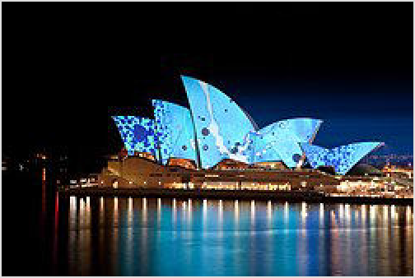May

The lights of Vivid Sydney
Vivid Sydney (http://www.vividsydney.com). Sydney's historic and landmark building illuminated. The best sights are around Circular Quay with the Opera House making an especially fantastic canvas. Martin Place is full of light shows and food stalls. And Barrangaroo laneways are decorated also. Some suburbs also have smaller light shows, including the centres of Chatswood and Parramatta. Expect large crowds and make sure to do some preparation – lots of road closures, light rail services get cut short to
Wynyard, while trains don't stop at Circular Quay (meaning you'll need to walk from Wynyard or St James). Free.
Biennale of Sydney (http://www.biennaleofsydney.com.au/). A contemporary arts and multimedia festival held in winter in even numbered years.

June
Sydney Film Festival (http://www.sff.org.au/). Shows over 200 movies in 16 days, including an enormous number of Australian and international movies, most of which will premiere at the festival.

July
Arabic Film Festival. Shows dozens of movies over a week at Parramatta.
The Rocks Aroma Festival. A homage to Sydney's love affair with coffee during a cold winter's day. Lots of artisan coffee stalls throughout the Rocks area. (updated Apr 2017 | )

September
Sydney Fringe Festival (https://sydneyfringe.com/). Features fringe art in the form of film, TV, performance and sport.
Lavazza Italian Film Festival (http://www.italianfilmfestival.com.au/). Showcases the finest that Italian cinema has to offer, picking contemporary films from the vibrant Rome International Film Festival to the more established events such as the prestigious Berlinale and the world-famous Cannes Film Festival; and a selection of Italian Classics from the archives of the Cinecittà Studios in Rome.
Sydney Underground Film Festival (http://suff.com.au/). The festival programs unique, quality independent films that transgress the status quo and challenge the conservative conventions of film making. The festival is devoted to renewing local interest in independent and experimental film as part of an international underground film culture and aims to change an ingrained culture of cinematic complacency and revitalise an enthusiasm for cinema.

October
Crave Sydney (http://cravesydney.com/). Showcases the city's best restaurants, established and up-and-coming young chefs, food and wine culture. "Hats off dinners", the night noodle markets at Hyde Park, and hands-on cooking classes. Food festivals and markets all around Sydney
Musica Viva Festival (http://www.musicaviva.com.au/the-library/musica-viva-festival). Sydney's premier chamber music festival. The festival presents a rich feast of masterworks and musical treasures played by some of the world's finest practitioners, interspersed with music of different cultures.

November
Sculpture by the Sea (http://www.sculpturebythesea.com/). Join tens of thousands of Sydneysiders as they take a leisurely walk between Bondi Beach and Tamarama Beach to admire the numerous larger than life sculptures set up at both beaches and along the walk. Bring a camera to take snaps of the weird and wonderful exhibits.

December
Carols in the Domain (http://www.carolsinthedomain.com/). Held annually in the Domain in the city centre on the last Saturday before Christmas. Attracts around 100,000 people (so plan to get in there early for a good spot) with candles sing along as night falls.
New Year's Eve. Features massive displays of pyrotechnics around Sydney Harbour and the Harbour Bridge (including fireworks shot from the bridge itself). There are two shows, a "family show" at 9PM, and the major fireworks display at midnight. Immediately following the 9PM Family Fireworks, the spectacular Harbour of Light Parade begins. Over 50 vessels make a majestic passage on a 15km circuit around the Harbour, featuring illuminated emblems representing the Sydney New Year's Eve theme, glittering either on their hulls or masts. Many of the hotels and bars near the Harbour hold special parties with high cover charges, and boat cruises sell for a premium. Or get in early for the free alternative with some cheese, fruits, wine, picnic blanket and some friends on a warm summer night by the harbour. Save some sympathy for Northern Hemisphere cousins freezing in Times Square waiting for all the excitement of a ball dropping by a couple of metres.

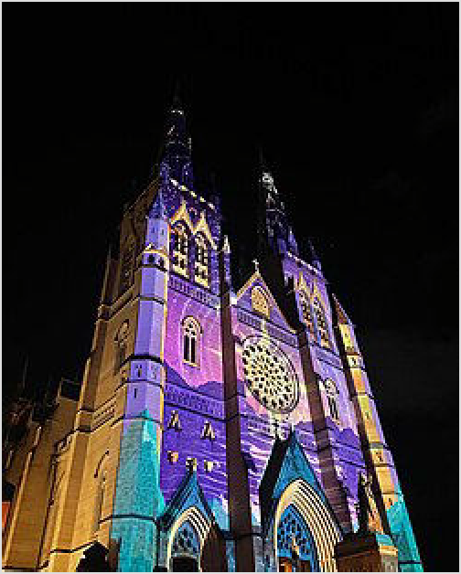Learn

Happy New Year's festival in Sydney

You can take language classes, join a cafe book group, learn to draw, sign up for historical or foodie walks, or take computer or business classes at City of Sydney Library, where you can sign up to borrow books or just read magazines in their café as well.

Universities
Unsurprisingly as Australia's second-largest city, Sydney is home to many universities. Two of these universities, the University of Sydney (http://sydney.edu.au/) and the University of New South Wales (http://w ww.unsw.edu.au/) are part of the prestigious "Group of Eight". There are opportunities for international

students to enroll in these universities, either in their degree programs or through exchange agreements with foreign universities. These provide foreigners with an excellent opportunity of live in Sydney for an extended period.

Buy

See the Sydney District Pages for things to buy in the CBD, and other Sydney districts.

Most stores will accept VISA/Mastercard credit cards, and only a few take only cash. American Express is generally accepted only at larger stores.

Currency exchange
As with the rest of Australia, currency exchange offices operate in a free market, and the small convenient exchange booth you pass on George Street, by the Opera House or at the airport can charge 15% or more over the best rate you can obtain elsewhere. As always, check rates and commission carefully. Know today's rate and be prepared to walk away if the amount of money they calculate isn't what you would expect. Banks typically offer much better rates, but are only open business hours on weekdays.

You may find it better to pay by credit card and use ATM withdrawals and have the certainty of getting the rate and fees provided by your bank.

- KVB Kunlun (http://www.kvbkunlun.com/en/), 18F, Citigroup Centre, 2 Park St, ☏ +61 2 8263 0188, info@kvbkunlun.com (mailto:info@kvbkunlun.com). This large trading company mainly deals with businesses and big amounts but they also exchange money for individuals with smaller amounts. They charge you $10 if you exchange under $2,000 but their rate is so competitive that it's still worth going there for changing a few hundreds. They have by far the best rate in Sydney. Be prepared to wait as some travellers have been reporting to be there for over an hour. (updated Oct 2016 | )

Opening hours
Main department stores and specialty stores open around 8 or 9AM and close around 6 or 7PM, staying open until 9PM on Thursday. On Sunday expect them to open around 10AM in the suburbs, and around 11AM in the CBD, and to close at 5PM. There are a few locations where you will find shops opening a little later, such as Darling Harbour which is open until 9PM every weeknight.

Large supermarkets will be open from 6AM until midnight.

Many convenience stores, fast-food restaurants and petrol stations within the Sydney metro area are open 24 hours a day.

Banks will usually only open weekdays, with only an occasional branch opening Saturday morning. Travel agents (not including booking agents in tourist areas) close on Sundays.

Souvenirs
Those quintessential Aussie souvenirs - stuffed koalas and kangaroos, various "Australiana" knick-knacks - can be found in any souvenir store around the city, as well as in airport shops. Authentic Aboriginal/indigenous arts and crafts, such as traditional paintings, hand-made didgeridoos, are expensive, and the range in Sydney is much smaller than in Alice Springs. For those who only wish to take home a replica, as a memento of their trip to Australia, head to Paddy's Markets (http://www.paddysmarkets.com.au/) in the Haymarket area of the southern end of the city. The markets also sell a huge range of souvenirs at much better prices than regular souvenir stores. Dollar shops (see "Food and Essentials" below) also sell souvenirs at bargain- basement prices, albeit at a much reduced quality.

Fashion
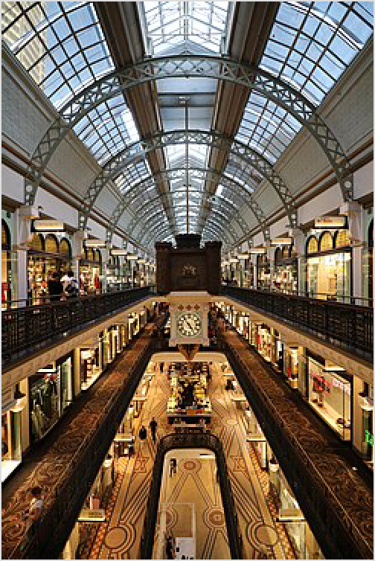Australia's unique style and creativity means Sydney is developing on the international fashion circuit, as designs from Australians such as Wayne Cooper, Collette Dinnigan, Akira Isogawa, Lisa Ho, Oroton and Easton Pearson are seen around the globe. In fact, around 60 Australian labels are export their designs to boutiques and department stores in Asia, Europe and the United States.

Interior of the Queen Victoria Building
The greatest concentration of clothing and accessories stores are to be found in the northern half of the CBD, starting from the Town Hall precinct, neat the Queen Victoria Building.

Queen Victoria Building – in the City Centre, a renowned, beautifully maintained, 19th century sandstone building, home to over 400 stores. The stores in the building are laid out in a hierarchical style- literally. The basement level has cheap, casual- fashion stores with a food court, the street level mid- range brand-name chains and level 3 is where various Australian designers, some European labels
and Italian shoe stores are. It is one of Sydney's more photogenic pieces of architecture. It's on George St adjacent to Town Hall and Pitt St Mall.
The Strand Arcade – In the City Centre, remains a majestic beauty in the middle of the hustle and bustle of Sydney's CBD. Many retailers including The Nut Shop, Elie's Leather Repair and Strand Hatters have traded for decades, becoming well known Sydney institutions. Today the centre is a unique mix of Australian and International designer fashion (including Alex Perry, Akira, Lisa Ho and Alannah Hill) and specialty stores catering for a discerning, sophisticated clientele.
Castlereagh Street in the City Centre is lined by many of Sydney's most expensive European-label boutiques and jewellery stores. It is also home to the flagship store of Australian department store chain David Jones.
Department stores. There are only two of these in the City Centre, Myer (https://www.myer. com.au) and David Jones (http://www.davidjones.com.au), which are practically next door to each other near the Pitt Street Mall, and joined by an above-ground covered pedestrian walkway. Both offer your standard department-store range of goods.

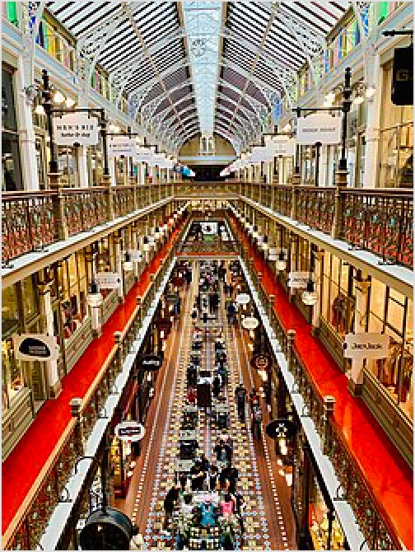Pitt Street Mall is a pedestrian mall in the City Centre. It is one block long between Market Street and King Street and is one of the world's most expensive shopping streets. The entire east side of the block comprises the Westfield Sydney mall (including Sydney Tower) and the west side is also a series of shopping centres.
The Strand Arcade
Oxford Street just east of the city is lined with shops, bars and nightclubs. The section between Taylor Square and Queen St, Woollahra is particularly good for mid-high end Australian fashion designers and boutiques. Some of these boutiques and other fashion retailers sell at Paddington Markets (http://ww w.paddingtonmarkets.com.au), which are held in the grounds of the Paddington public school every Saturday from 10am.
Queen Street in Woollahra also east of the city is an upmarket shopping destination with high-end boutiques, food and homewares stores.
King Street, Newtown in the inner west is a long strip of inexpensive boutiques, and the odd chain store, with plenty of places to stop for a coffee or wine along the way!
Shopping malls (http://www.westfield.com.au) – There are several large shopping malls around Sydney in Bondi Junction, Chatswood, Parramatta, Macquarie Park, Hurstville and Miranda, as well as Warringah Mall. The Bondi Westfield offers the most upmarket experience, with many European fashion labels available.
Factory outlets. Birkenhead Point and DFO in the Inner West have brand name fashions at discount prices. Market City in Chinatown also has a few smaller factory outlets.

Food and essentials
Many city corner shops call themselves "supermarkets", but are just overpriced convenience stores. It is worth seeking out actual supermarkets, which can be found even in the CBD: the main two are Woolworths (http://www.woolworths.com.au) and Coles (http://www.coles.com.a u). Aldi (http://www.aldi.com.au) is a cheaper alternative, but confined to the suburbs.

Postcards
Postcards are least expensive at post offices (75c) or discount stores. Convenience and souvenir stores may sell a wider range of (more expensive) postcards, but generally they do not sell stamps. An overseas stamp for a postcard costs $2.60 [1].

Eat
This page uses the following price ranges for a typical meal for one, including soft drink:
Budget Under $15

Prices in Sydney's restaurants vary. Breakfast at a standard cafe (food plus a coffee or juice) can cost anywhere up to $20 for a full English breakfast or other substantial meal. A main meal in a mid-range restaurant is around $25 - $35. Upper mid-range averages around $35 - $45. At the real top-end places a dinner for two with wine can run up to $400-500 and beyond.

For the more budget-conscious, Sydney's multicultural demography means plenty of quality ethnic cuisine for cheap eats, particularly Asian restaurants in Chinatown where rock
Mid-range $15-50
Splurge Over $50
bottom priced food (but no less tasty) can be found. Plonk down at a laminate table shoulder to shoulder with hungry locals for some bubble tea and a sizzling plate of delicious Asian food. Many restaurants in the city will also offer "lunch specials". For example, a good Korean "set lunch" can be found for less than $15. A bowl of noodles in Chinatown will run you $8 or $9. Some Thai curry with rice at any of the many restaurants all over Sydney will cost about $10.

Newtown in Sydney's inner-west (approx 4km from the CBD) is renowned for its inexpensive cafes and restaurants on King St, in particular Thai food. It is highly popular among students from the nearby University of Sydney.

Fine dining
Sydney is also home to some of the world's best restaurants and their chefs. But if you want to try Sydney's finest rated restaurants during your visit, a booking must usually be made well in advance. There's Est in the City Centre, Marque in the City East and Flying Fish Restaurant & Bar in Pyrmont. Another famous Sydney celebrity chef is Neil Perry, who runs Rockpool at The Rocks, as well as the Rockpool Bar and Grill in the city, not far from Circular Quay, with Spice Temple downstairs.
If you want to splurge on the location, try Quay in The Rocks or Matt Moran's Aria, both of which have harbour and bridge views.
For fine dining away from central Sydney, try Jonah's in the far Northern Beaches - go for lunch, the view is stunning.

Takeaway
Takeaway (takeout) food in Sydney can be as cheap as buying the ingredients and making it yourself, and many stores specialise in take-away food. There will usually be a picnic table, park or beach nearby to eat whatever you can select. Quintessential Aussie takeaways include the meat pie (minced beef with gravy sauce in a crusty pastry shell), sausage roll (sausage mince in a puff pastry casing), usually topped generously with tomato sauce/ketchup, and fish and chips (inherited from the British to be sure but loved by all Australians).
Most restaurants will do take-away food as well, but almost certainly at a premium to the cost of buying food from a take-away. Outside of the city an occasional restaurant may offer a 10% discount for take-away. There are a few online services like Menulog (https://www.menulog.co m.au/) that allow users to order food online from the variety of restaurants and take away in a particular area.

Eat streets
Just about every suburb in Sydney has a restaurant or two, a cafe or coffee shop, and a place that sells takeaway food. However, there are a number of places in Sydney where you can window shop through many restaurants and make your choice.

All of Darling Harbour is like this, there are restaurants of every variety all along the waterfront. East Circular Quay in the City Centre is similar, along with the International Passenger Terminal on the west of Circular Quay - however many of the restaurants in this area are expensive and loved more for the view than the quality of the food. There are (pricey) exceptions, such as Cafe Sydney, Aria and Sailors Thai.

In the east of the city, Victoria Street in Darlinghurst and Crown Street in Surry Hills (between Oxford and Cleveland Streets) has a large range of funky cafes, small bars, pubs, patisseries and restaurants. Darlinghurst and Surry Hills has it all, from cheap Asian take-aways to high end restaurants. Many trendy restaurants in this area don't take bookings; often you wait at the bar for a table. These suburbs are popular with hipsters, yuppies and the gay community.

Just east of the city is Woolloomooloo Wharf which boasts a fantastic view across the harbour and several upscale restaurants, including excellent steak, Chinese, Italian and seafood restaurants. Perfect for lunch on a sunny day.

King Street, Newtown, centred on the railway station, has a constantly changing selection of good value restaurants, pubs, cafes and bars. You can find many various types of cuisine here; mainly cheap Thai, but also Vietnamese, Italian, Turkish, Japanese and modern Australian. This area isn't touristy, but popular with students from the nearby Sydney University. The area has its own alternative style, which makes for great people watching.

On the Lower North Shore, Willoughby Road at Crows Nest has consistently good Indian, Japanese, Thai, steak, and a handful of small bars. Military Road through Cremorne and Neutral Bay have a smattering of decent restaurants, mostly Japanese. Kirribilli has a few nice cafes and restaurants, and a short after dinner stroll will take you by some of the best views of the Sydney Harbour Bridge.

In Macquarie Park, Rowe Street in Eastwood has built a reputation for some of the best East Asian food in Sydney. With everything from cheap eat Chinese noodle stands, smokey Korean BBQ houses and posh Japanese restaurants, Eastwood has something for every taste and budget. On Saturday nights there is a night market in the plaza with a number of stalls selling street food style snacks and treats.

Parramatta, to the west, has an eating strip, many with alfresco options. Harris Park nearby is Sydney's Little India with a good number of very affordable, authentic Indian restaurants.
In the North West district, Castle Hill has many restaurants on Terminus St as well as at "The Piazza" which is adjacent to Castle Towers shopping centre and features a pleasant, lively atmosphere with a fountain in the centre of the ring of restaurants.

Modern Australian
Thanks to Sydney's (or rather, Australia's) multicultural mix, "modern Australian" is usually characterised by a fusion of cuisines. Think entrees spiced with a Thai-inspired chilli dressing, mains with a hint of a Chinese-style ginger-based marinade or sunny Tuscan flavours- all in the same menu. Many of Australia's celebrity chefs are of ethnic backgrounds, and many have trained overseas, bringing with them a world of experience back home.

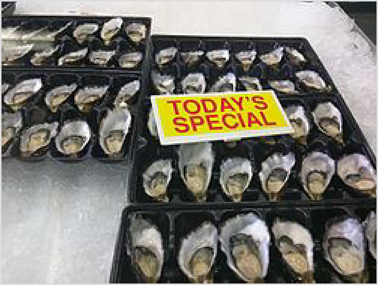Visit the Sydney Fish Markets in Pyrmont (within walking distance of Darling Harbour) for a lunch of fresh seafood of almost any description. Sadly the cooked seafood on offer is overpriced, greasy and frankly an embarrassment. Avoid. For a proper seafood lunch at the fish markets, bypass these shops and go directly to one of the many fishmongers. Pick out the best freshly shucked oysters, cooked Balmain Bug or lobster tails, glistening prawns and sashimi. Take it out to tables outside and enjoy getting your hands dirty.

Oysters at Sydney Fish Market
Otherwise, head upstairs to Fisherman's Wharf Chinese Restaurant for some wonderful Cantonese seafood or yum cha.
Hit a steakhouse and try Australia's world-famous prime Angus beef. Easily accessible upmarket Sydney city steakhouses include I'm Angus at Darling Harbour, Prime and Kingsley's in Woolloomoolloo in the City East. For a truly top end experience of some of Sydney's very best steak and seafood in luscious deco setting, try Neil Perry's Rockpool Bar and Grill in the CBD. Dress up and bring your Amex.
Alternatively, many CBD pubs offer $6 to $10 steak "meal deals", provided that you also order a particular alcoholic drink at the same time. You can also go to Phillip's Foote at The Rocks to cook your own steak on a BBQ.

Multicultural
For those who are after authentic multicultural culinary experiences, there are unique "food districts" scattered around the greater city. The range of food available is huge and isn't necessarily expensive. It is usually possible to find a restaurant of any nationality, specialising in almost any cuisine.

Assyrian in Fairfield and Fairfield Heights, in Greater Western Sydney, in Ware Street and Smart Street.
Chinese (Cantonese) in Chinatown, Chatswood on the North Shore. For more northern Chinese flavours, including Shanghainese and Pekingnese, head to Ashfield and Burwood. Some outer suburbs are particularly known for their Chinese restaurants - recommended examples are Eastwood in Macquarie Park, Parramatta (west) and Hurstville in Sydney's southern suburbs which all have a number of restaurants offering more home-style Chinese food. They are all accessible by public transport. There are also good options to be found in Kingsford near the University of New South Wales.
Indian in one of the many restaurants in the Outer West with all types of Indian cuisine (North Indian, South Indian, vegetarian, meat, etc).
Indonesian in Anzac Parade, Kensington, Kingsford & Maroubra.
Italian in one of the restaurants in Leichhardt's Norton Street, or nearby Ramsay Street, Haberfield in the Inner West. Or in Stanley St in East Sydney - a walk from the CBD.
Japanese in Neutral Bay or Crows Nest in the Lower North Shore and Eastwood in the Macquarie Park district.
Korean in Liverpool & Pitt St in City, Strathfield, Eastwood and Campsie.
Kosher in Bondi. Many great restaurants throughout the area.
Lebanese in Cleveland Street. Baba Ghanouj, Lahem Begin and Baclawa here. For the very best Lebanese, head out to the Middle Eastern enclaves of Greenacre or Lakemba.
Nepalese in Glebe Point Road, Glebe, in the Inner West.
Portuguese in Petersham in the Inner West.

Spanish in Liverpool Street in the city.
Thai in one of the many low priced Thai outlets in Newtown's King Street in the Inner West although Thai can be found anywhere in Sydney. Although for some reason where ever Indian food dominates, the Thai food does not tend to be very popular.
Turkish in Auburn. Closer to the city, there try Enmore Rd Enmore / South King St Newtown in the Inner West. Get your Sucuklu and Pastirmali here.
Uyghur on Dixon Street, Haymarket (Chinatown)- fiery, flavour-bursting food originating from the Turkic regions of Central Asia.
Vietnamese in Marrickville. The most authentic Vietnamese can be experienced in Cabramatta or Bankstown. If you have the time, Cabramatta particularly is a fascinating and worthwhile day trip. So awash is the suburb with Vietnamese restaurants, groceries, butchers, craft shops, clothing stores and restaurants - not to mention Vietnamese people - you'd swear you were walking around Saigon rather than Sydney.
Yum cha in Chinatown is very good, arguably even better than Hong Kong since many of their best chefs moved to Sydney in the 1990s. Yum cha is an entire meal comprising many small dishes called "dim sum" (Mandarin: dian xin). The food moves in roving, heated trolleys around the restaurants, although some places have now abandoned the trolleys and instead give you a menu to tick your items which will be brought to your table. Some only have trolleys for specials or on weekends. Expect queues on weekends and brusque service all days - it's all part of the charm of yum cha.
Many of the areas mentioned above also sell produce related to the original nationality of the locals.

Food festivals
It always seems like there's a food festival occurring every weekend in one of the suburbs of Sydney. Usually the idea is that restaurants take part, providing smaller portions of their signature dishes around $7-$12 a plate. Some also focus on ethnic cuisine — a great opportunity to sample unfamiliar food. Look out for the Sydney International Food Festival (https://www.facebook.com/ p/Sydney-International-Food-Festival-10006686117151 0/), a major festival which showcases Sydney's food culture. It's held in October, and includes the night noodle markets operating in Hyde Park in the City Centre.

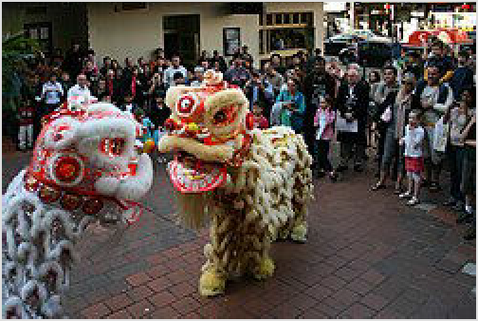Lion dancing during the Sydney International Food Festival

Vegetarian and special diets
Vegetarians are well catered for. Every restaurant will usually have at least one vegetarian dish. Indian restaurants can be relied upon to provide a wider selection. The trendy East Sydney and Inner West suburbs have many choices, Cabramatta in the western suburbs have many Asian Buddhist cuisine restaurants that are vegan and vegetarian.

There is an awareness of gluten-free and dairy-free diets in Sydney, and again the more trendier inner city suburbs are more likely to cater for these diets.

Customs
Cafés serving breakfast start opening at 6AM and breakfast is usually served until 11AM, or occasionally all day. Orders for lunch start at about noon and continue until about 3PM. Many cafes will start closing late afternoon, although a few may remain open for dinner.

Restaurants usually open for dinner around 5PM-6PM and while there are exceptions (usually concentrated in areas with active nightlife), last orders for dinner are typically taken around 10PM. Restaurants in business areas open for lunch as well. It is common for restaurants in suburban locations to sometimes be closed on Sunday, Monday or Tuesday nights.

It is more expensive to get a sit down meal in the evening, than it is for lunch.

Dress codes
Australians are casual. While most people make an effort to dress up for fancier restaurants, there is no requirement and both restaurants and diners alike are relaxed about dress standards. There are no restaurants in Sydney that require jackets for men for instance (not true there are a few exclusive restaurants and clubs that do require jackets), and jeans (nice - no holes) are common in even the most expensive and posh Sydney restaurants. Wear whatever you feel comfortable in.

Publications
The Good Food Guide, published by the Sydney Morning Herald, is a well-regarded restaurant guide on the Sydney food circuit. The guide uses a reviewing and scoring system similar to the Michelin publications overseas. While the majority of restaurants included are in Sydney, a number of regional NSW restaurants are also included. The GFG can be picked up at any good book store and is also available for download as an iPhone application, with monthly or yearly subscription options.
Timeout Sydney has a regular section on eating out in Sydney, with emphasis on affordable destinations. There is a paper publication as well as a web site.
For the well-heeled and truly gourmet, the glossy pages of Gourmet Traveller magazine cover the latest in Sydney food fashion and the upmarket restaurant scene.
Eatability.com and Urbanspoon are websites similar to Yelp! in the USA, containing reviews and rankings of restaurants by the masses.

Drink

Sydney has an enormous number of places to drink and party. There is a burgeoning scene for quirky and unique small bars, and the city's cultural life has enjoyed a refreshing growth in night-time choices. There's a litany of clubs and venues for entertainment, and as with most Australian cities, Sydney has a strong live music scene. The majority of pubs and smaller clubs close before 3AM and some as early as midnight, particularly if there are nearby residents. A limited number of venues have 24-hour licenses.
Busy venues will have door staff checking photo identification to determine that you are over 18. Admission is also commonly refused to those who seem visibly drunk. More popular venues have discriminatory door practices, the most common of which is refusing entry to groups of men who are not accompanied by women. Some pubs and most clubs will admit children accompanied by

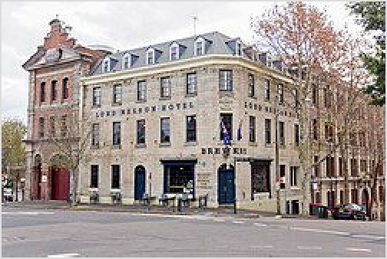adults as long as they don't approach the bar or enter an area where there is gambling, particularly earlier in the evening. Check with staff at the venue. Some pubs don't provide a nice environment for children some nights.

Many places have at least a basic dress code, enforced all hours in the city, and usually after 7PM in the suburbs. For most generic pubs, men should wear closed toe shoes (not running sneakers), full-length pants, and a shirt with sleeves (not a singlet). For clubs, men should don neat business-style shoes. In almost all cases, women can dress more freely, but a small number of places require closed shoes or dressy sandals or high heels.

The Lord Nelson Hotel in The Rocks, one of several claimants to be the oldest pub in Sydney

Many pubs are called hotels, but only very few can ever offer you a place to sleep. Hotel pubs are usually found on a street corner with at least one ground-floor bar, and are usually a few floors high (though not all floors may be open to the public).

Entry charges for live music or DJs are usual and range from $5 to $30 depending on clientèle. Entry charges are rare if you're going into a pub for a drink.

There is a taxi shift change at 3AM, and it is notoriously difficult to catch a taxi anywhere between 2:30AM and 3:30AM, but Ubers are out in force at this time of night.

Some types of nightlife are concentrated in particular areas:

Backpackers drink near the hostels, and will find a lot of fellow budget travellers in pubs in the Eastern Suburbs Beaches like Bondi Beach and Kings Cross in the City East
In some ways Irish pubs are a global phenomenon, but they've certainly taken Sydney by storm. Irish pubs are concentrated in both The Rocks area and the southern area of the city. They are outrageously popular on the 17th March for St Patrick's Day.
Sydney's large gay scene is concentrated on Oxford Street in City East although it still has a large range of pubs and clubs for all ranges of sexuality and is a prominent nightspot for many party-goers. Sydney's queer community also can often be found on King Street in Newtown which offers a more relaxed place to gather and far fewer yobs.
Sydney's bohemians, artists, and students mostly hang about in the Inner West. King Street in Newtown is littered with great joints. Try the Midnight Shift or Corridor for awesome music and a low key vibe. Bloodwood is a must for killer Bloody Marys. The Courthouse is everyone's local, either that or the Town Hall Hotel, which is open the latest on the strip.
Hook round to Erskineville Rd. for even more choice of unique places. A meal at The Rose on a sunny afternoon is a must. Opposite the Hive Bar will have eccentric DJs spinning rare dub 45's. Surry Hills is also a hot spot, with many of the larger venues that host bigger events. The Oxford Arts Factory and The Standard, both on Oxford St., are two great venues where you'll catch larger touring bands and other acts. Yulli's on Crown St have excellent drinks. The Flinders host local bands and has an American dive bar flavour. Try student bars Manning at Sydney Uni, the Roundhouse at UNSW and the Loft at UTS which all offer pleasant, hassle free environments, and no one checks if you're a student. Manning Bar is also great for a meal as they have their Manning BBQ. The Clare opposite UTS on Broadway, though very ratty looking, is a similarly popular place for students. There are many great bars and pubs on Broadway, such as the Lansdowne Hotel which also offers cheap lunch meals for $5-6 on some days of the week.
Nightclubs are mostly found in the Kings Cross area. This is the central party district for late club nights. There are also clubs in the CBD, Surry Hills (along Oxford St.), and Darling

Harbour. Try The Kings Cross Hotel for many levels of local bands and DJs. Nearby the World Bar is a must for more great entertainment. Frankie's Pizza in the CBD absolutely has the best vibe and music in town.
Sydney has a big scene for microbreweries, including The Lord Nelson (The Rocks), The Schwartz Brewery (City), Young Henry's (Newtown) and the Local Taphouse (Surry Hills).
Business pubs also cater to the city crowd: lawyers, financiers and brokers and are very busy Friday nights when the city workers are let loose for the week.
There are many great nightclubs in Sydney, but they are very spread out so it would be a good idea to get an idea of where you want to go. Check guides in Friday's newspapers, or the free guides available in music stores and youth clothing stores.

Sleep

Sydney has hundreds of accommodation options in the central Sydney area to consider, from backpackers hotels to five star hotels with harbour and Opera House views. However, there are options out of the CBD too.

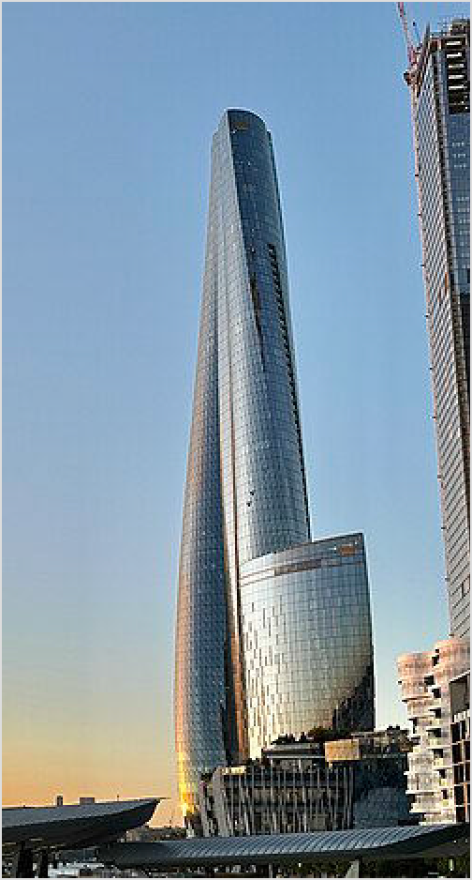If you are travelling on business, there may be business style accommodation near to where you are working, and there is usually no need to stay in the city. There are options around the commercial areas at the airport in Southern Sydney, around Macquarie Park in the North West, and at Parramatta.
If you are travelling with a car, then finding a place to park, and getting into and out of the city can be a hassle. The Hume Highway in Sydney's South West has the standard roadside motels where you can park by your room, with the service station or fast food outlet next door.

If you are into camping, the closest camping to the CBD is on the Cockatoo Island in the harbour. You can pitch a tent in Lane Cove National Park, less than 10 km from the CBD, around 750m from the train station at North Ryde.

If you are into the beach, Manly and Bondi are the two obvious places to consider. From Manly 25 minutes on the ferry has you right in the centre of Sydney. Some of

Crown Sydney, Sydney's tallest building and home to one of its most expensive hotels

the lesser known suburbs have accommodation options. Cronulla has beachfront accommodation, facilities and is the only beachside suburb of Sydney with a train station (45 minutes from downtown).

Budget
Sydney has a wide range of backpackers' hostels - popular districts for these include the southern half of the CBD and Haymarket, Glebe and Kings Cross, the Eastern Suburbs (Bondi, Coogee) and the Northern Beaches (Manly).

Mid-range
You find many mid-range accommodation providers within the CBD (mostly in the southern Haymarket end), and within a short distance of the city by public transport, including in North Sydney, the Inner West and the North Shore. Sometimes cheaper motel style accommodation can be obtained on the roads leading into Sydney, particularly in South Western Sydney

Splurge
Luxurious hotels can be found all over Sydney. The most expensive hotels are generally in the CBD and the Rocks district, near the business hub of Sydney, close to many restaurants, often featuring spectacular harbour views. Some other high quality hotels are in Darling Harbour. You may check the list below for specific locations.

Please visit one of the various Sydney districts described in the Districts section above to see the accommodation listings.

Serviced apartments
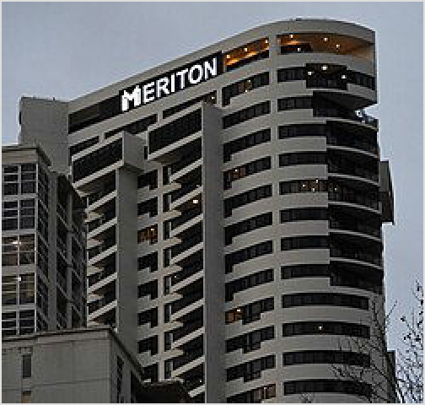Serviced, short-term apartments are widely available throughout Sydney and are available for stays as short as one night. Amenities typically include kitchen, washer and dryer, and separate bedrooms. A range of properties exist from budget to five-star.

Meriton George Street

Please visit one of the various Sydney districts described in the Districts section above to see the accommodation listings.

Read

Robert Hughes, The Fatal Shore - The early
chapters in this fantastically evocative treatment by a born and bred Sydneysider is a real eye-opener to Sydney's convict beginnings. Highly recommended.
John Birmingham, Leviathan - The Unauthorised Biography of Sydney - A history of Sydney from its beginnings as a penal colony to contemporary times. Non-fiction, it discusses incidents and themes in an anecdotal fashion. Definitely not your usual historical work.
Peter Carey, 30 Days in Sydney - A short "travel" novel from one of Australia's most esteemed authors. Utilising the fitting theme of "the elements" (earth, fire, wind & water), Carey retells stories of the "Rum Corps", near-death experiences (both on the water and in the inhospitable Blue Mountains) and even blatant police corruption. A compelling read for anyone wishing to appreciate the city, its peoples and their remarkable way of life.

Stay safe

See also staying safe in Australia

The Australia-wide emergency number is 000, with the ambulance service, fire department and police being available through this number.

Theft
Be on the lookout for the usual big city petty crime problems. Lock your car, and keep valuables safe or hidden. People begging may ask for money or cigarettes, but they are generally harmless. They will often make up the usual stories about needing a train fare etc. Simply say "Sorry mate" and they will usually leave you alone.

Violent crime
Sydney has some of the violent crime issues that plague major cities. However, in general, no special precautions are required visiting the typical tourist areas during the day.
Most assaults in Sydney take place in or near pubs and nightclubs at night, and involve alcohol. Most involve young males as perpetrators and victims. Most robberies occur in nearby quiet laneways, or parks close to pubs and nightclubs at night. The most common perpetrators or robberies are drug addicts. For this reason, take care around Kings Cross, The Rocks, Oxford St, and in George St between Town Hall and Central Station, especially late at night on Fridays and Saturday nights. Avoid Redfern station late at night. Even changing trains late at night is best done at Central rather than Redfern. Women should take extra care at bars and keep an alert companion at hand, especially in the central hostel area, and take precautions against spiked drinks.
Some areas of south-western and western Sydney have a reputation, generally gained by news reports of motorcycle and other gang related violence. However, if you want to venture out into these areas during the day, there is no exceptional risk. If you're planning to head way off the tourist trail to some suburban pub or nightclub for a night out, seek some local advice. It may be a nice pub, but it pays to be informed. Areas around railway stations tend to be hang-outs for youth gangs in Western Sydney, particularly on Friday and Saturday nights. Stay in company, and don't engage.

Public transport after dark
After 9PM, smaller outer suburban stations can be very quiet, and many are totally unstaffed after this time. The trains can also be empty when they get towards the end of the line at this time. Don't expect a taxi to be waiting at every station - only the major ones will have a well patronised taxi rank. Drunk people are common on trains late at night, particularly on Friday and Saturday nights. In the CBD, trains tend to be busy into the evening, and obnoxious behaviour is more common than any actual danger.

For your safety, travel in the carriage closest to the guard's compartment, which is marked with a blue light on the outside of the train. If you ever feel concerned for your safety on any train, or even if you encounter anti-social activity, you can call 1800 657 926 to speak with security, who can sometimes arrange for a transit patrol to board the train and provide assistance. You can also seek assistance from the guard. In more modern trains, you can press the button in the entry area to contact the guard. Every train station has an orange emergency help point monitored by CCTV that connects to security, usually towards the centre of the platform.

Nightride buses, which replace trains after midnight, can arrange for a taxi to meet you when you get off. Ask the driver.

Beachgoing
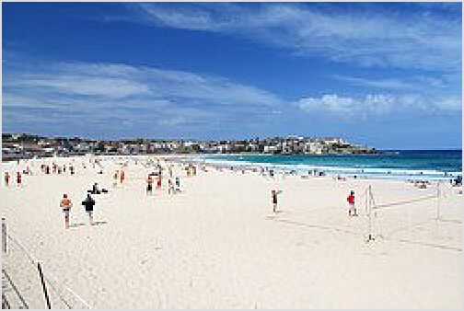If you are going to the beach, take the same precautions as you do anywhere in Australia. See Australia beach safety.

The main thing to remember when swimming at any beach is to swim between the yellow and red flags. These flags are placed by the lifeguards and indicate the safest place to swim at the beach away from dangerous currents.
Sydney has no really dangerous jellyfish. Bluebottles (Portuguese Man-Of-War) are blueish-purple stingers

Bondi Beach - Australia's most famous beach

that hit the Sydney beaches a couple of days every summer, when the wind direction is right. They have an air-bladder that floats on the water, and stinging tentacles. Often the air-bladder can be no bigger than a coin. You will see the evidence of them with their air-bags washed up on the beach if they are present. They can give a painful sting - even when on the beach - but it won't keep everyone out of the water. Apply a heat pack if you can, or ice, or salt water. The best way to remove the pain is to run the affected area under the hottest water you can stand. Vinegar is useless. Sometimes small transparent jellyfish appear in the harbour and estuaries. You can usually avoid any groups of them, but they are mostly harmless. More rarely larger purple jellyfish are in the harbour and other estuaries. If you see these in the estuaries, best to stay out of their way. Probably more of an issue to water skiers than to swimmers.

Sydney ocean beaches all have shark mesh nets around 100 metres out to sea, and are regularly patrolled by air for sharks. A shark alarm will sound if any are sighted, and you should get out of the water. The risk of shark attack swimming on a patrolled beach between the flags is low. Shark attacks are rare on Sydney beaches, but they have occurred. Advice is to avoid swimming in murky water after storms, or at dusk or at dawn, and to swim in the netted enclosures within the harbour and other estuaries.

Scams
Tourist scams are relatively uncommon in Sydney as is the case throughout Australia, but a common scam is for people posing as Buddhist monks to give you a piece of paper with religious symbols on it, and as soon as you have touched it, they will ask you for money which they claim is

to help build their temple – this is particularly prevalent in the CBD. However, many of them will back away if you verbally confront them, though.

Stay healthy

If you need an ambulance, call 000.

Medical centres with general practitioners are available for minor ailments without an appointment around the city and suburbs. Expect to wait around an hour or so to see a doctor. Upfront charges are usually around $75 for a standard 15-minute consultation, and most centres accept credit cards. Many medical centres remain open until 10PM or so, and a few remain open 24 hours. Those with an Australian Medicare card will find many medical centres in Sydney that "bulk-bill".
Most hospitals in Sydney have emergency departments, but check before attending as some do not. Those emergency departments are open 24 hours. See the Australia article for more details on health charges.

Many pharmacies stay open after normal business hours, often in proximity to medical centres, and there are a few that stay open 24 hours. You can call ☏ +61 2 9467 7100 to find the location of your closest after hours pharmacy.

Smoke haze
Relatively speaking, Sydney has low levels of pollution compared to other major world cities. There are however regular burn-offs of vegetation around Sydney and its surrounds during cooler and dry periods in order to reduce the risk of bush fires through summer, and these can lead to heavy smog over the greater Sydney area. Asthmatics and others with respiratory problems should take care not to spend too much time outside during these days. Wearing a P2 or N95 mask is a must during days of high pollution levels.
Sydney sometimes experiences high levels of smoke due bushfires, the most recent being December 2019. It was enough to warrant (temporary) inclusion in the world's top 10 polluted cities and the smoke was severe enough to prevent most outdoor activities. Although widespread bushfires are not a regular occurrence, scientists point to more happening in future due to global heating.

Connect

See the Sydney district guides for local information, or the Australia guide for broader options.

Cope

Consulates
All embassies are in the nation's capital of Canberra, however consulates in Sydney generally have most of the facilities that a traveller could need:

Canada (https://www.canadainternational.gc.ca/australia-australie/), Level 5, Quay West Building, 111 Harrington Street, ☏ +61 2 9364-3000, sydny@international.gc.ca (mailt o:sydny@international.gc.ca). (updated Feb 2022 | )
China (http://sydney.chineseconsulate.org/), 39 Dunblane Street, Camperdown, ☏
+61 2 8595-8002. 8:30AM-noon; 2-5PM. There is also a Chinese Visa Application Service Center (https://bio.visaforchina.org/SYD2_EN/) on 140 William Street
Egypt (http://www.mfa.gov.eg/english/embassies/Egyptian_Consulate_Sydney/Pag
es/default.aspx), Level 3, 241 Commonwealth St, Surry Hills, ☏ +61 2 9281-4844, fax: +61
- 9281-4344, info@egypt.org.au (mailto:info@egypt.org.au). 9AM-3:15PM.
France (http://www.ambafrance-au.org/-Consulat-general-a-Sydney-), Level 26 - St Martins Tower 31 Market street, ☏ +61 2 92 68 24 00, inscription.sydney@diplomatie.gouv.fr (mailto:inscription.sydney@diplomatie.gouv.fr).
Germany (http://www.australien.diplo.de/), 13 Trelawney Street, Woollahra, ☏ +61 2
9328-7733, fax: +61 2 9327 9649.
Greece (http://www.mfa.gr/sydney), Level 2, 219-223 Castlereagh St, ☏ +61 2 9264-
9130, fax: +61 2 9264-6135, grgencon.sid@mfa.gr (mailto:grgencon.sid@mfa.gr).
India (https://cgisydney.gov.in/), L1, 265 Castlereagh St, Sydney CBD, ☏ +61 2 9223
2702, fax: +61 2 9231 2299, cons.sydney@mea.gov.in (mailto:cons.sydney@mea.gov.in). 9AM–5:30PM. (updated Mar 2026 | )
Indonesia (https://www.kemlu.go.id/sydney/id/default.aspx), 236-238 Maroubra Rd, Maroubra, ☏ +61 2 9344-9933. For jurisdiction area of New South Wales, Queensland, ACT, and South Australia
Japan (http://www.sydney.au.emb-japan.go.jp/), Level 12, 1 O'Connell St, ☏ +61 2
9250-1000.
New Zealand (https://www.mfat.govt.nz/en/countries-and-regions/australia-and-paci fic/australia/new-zealand-high-commission-to-australia/), Level 22, 20 Bond St, ☏ +61 2
8256 2000, nzcgsydney@bigpond.com (mailto:nzcgsydney@bigpond.com). By appointment
only. (updated Mar 2024 | )
Pakistan (https://pakconsulate.org.au/), 3/109 Pitt St (Near Mejico restaurant), ☏ +61 2 9223 0140. 9.30AM-1PM. (updated Aug 2023 | )
Papua New Guinea, 247 Coward St. 9.30AM-1PM.
Romania (http://sydney.mae.ro/), Ground Floor/83 York Street, ☏ +61 2 92993764, sydney@mae.ro (mailto:sydney@mae.ro). General Consulate
Thailand (https://sydney.thaiembassy.org/), Level 8/131 Macquarie St, ☏ +61 2 9241 2542. 9AM-1PM.
Taipei Economic and Cultural Office (http://www.roc-taiwan.org/AU/SYD/mp.asp?m
p=661), Suite 1902, Level 19 MLC Centre, King St., ☏ +61 2 9223 3233, fax: +61 2 9223-
0086, syteco@bigpond.com (mailto:syteco@bigpond.com).
United Kingdom of Great Britain & Northern Ireland (https://www.gov.uk/world/orga nisations/british-consulate-general-sydney) (British Consulate General Sydney), Level

22, 20 Bond St, ☏ +61 2 8247 2200. By appointment only. Phone is available 24/7 for enquiries and emergencies.
United States of America (https://au.usembassy.gov/embassy-consulates/sydney/), Level 59, MLC Centre, 19-29 Martin Pl, ☏ +61 2 9373-9200, fax: +61 2 9373-9184. Make sure to use the facilities before going through security as there are none in the Consulate itself. There are shops in the malls below offering passport photos and a post office where you can buy pre-paid, tracked, envelopes.

Other services
Custom Luggage Repair Centre, 317 Sussex St, ☏ +61 2 9261-1099. Luggage repair services.
Newspapers. Sydney has two major dailies: The Sydney Morning Herald (http://www.smh.co m.au), which is considered the city's newspaper of record, and a populist, generally right- leaning tabloid, The Daily Telegraph (http://www.dailytelegraph.com.au). Leafing through the Herald can be a good way to get an idea of what's happening in the city, and of attempting to understand the complicated morass that is Sydney politics. Newsagents also stock The Australian (http://www.theaustralian.com.au), a right-leaning national broadsheet, and The Australian Financial Review (http://www.afr.com), as well as one or more local suburban papers (usually weekly, although larger ones publish more often).

Go next

There are a number of good one or two day trips from Sydney:

Drive across the B59 Bells Line of Road over the Blue Mountains to the Western Plains. Buy produce (apples, pears, chestnuts and berries) from the orchard vendors at the side of the road if driving over in autumn. A few of these orchards also offer pick-your-own. Towns to stop by include Lithgow, which is at the foot of the mountains; Bathurst, home to the Mount Panorama motor racetrack, and Orange (3 hours from Sydney), a beautiful rustic town with a great (cold climate) wine district and several fantastic restaurants by eminent chefs, and which is fast becoming a wine-and-foodie region of New South Wales to upstage the Hunter Valley.
Travel up into the wilderness area of the Blue Mountains. There are a number of good day walks in the Katoomba area, or you could tour Jenolan Caves.
Royal National Park, in the south of Sydney and accessible by train has nice 1 to 2 day walks.
Newnes Glen in Wollemi National Park. Kanangra Boyd National Park.
Take a tour of the Hunter Valley wineries.
Wollongong is a lovely small city south of Sydney, accessible by driving south down the A1/M1 (Princes Mwy) or taking an hourly train.
Head up to Gosford or Woy Woy for some quieter, but picturesque beaches. Both of these towns are accessible by the Central Coast and Newcastle train.
Head up to the regional city of Newcastle by train and take in some of the Victorian architecture and fantastic city beaches.
Or if you are moving on:

Melbourne - Australia's cultural and sporting capital. See also: Sydney to Melbourne by car for itinerary information.
Auckland - It's 1,000 km closer and often cheaper to get to Auckland than it is to get to Perth.

Alice Springs - 3,000-km drive. At least a 3 night trip, stopping at Hay, Adelaide & Coober Pedy.

Routes via Sydney
Sydney ← Adelaide ←  Bathurst ← Lithgow ←  END ←  Newcastle ← Central Coast ← | W |  | E | → END  → END  → Mittagong → Albury  → Wollongong → Kiama
 | W A32 E NE M31 SW N M1 S

Retrieved from "https://en.wikivoyage.org/w/index.php?title=Sydney&oldid=5270707"

